Name

Mathematics Standard Year 11
Networks Paths Trees

Book 1 |  | Version: 261007  Feedback:  https://MrDingMaths.com
Contents
Syllabus Content 2
Introduction to Networks 3
Weighted and Directed Graphs 11
Walks and Paths 16
Trees and Spanning Trees 22
Minimum Spanning Trees 28
Minimal Connector Problems 33
Shortest Paths 39

Syllabus Content
MST-11-07 applies network techniques to solve network problems
Network concepts
- Describe a network as a collection of objects (vertices) interconnected by lines (edges) that can represent systems in the real world
- Define and use the network terminology: vertex, edge, degree, directed networks and weighted edges
- Examine circumstances in which networks are used in a variety of real-world applications
- Construct a network diagram to represent information from a given table or map, showing weighted and directed edges
- Solve problems involving network diagrams in a variety of practical contexts
Shortest paths and spanning trees
- Define and use the network terminology: path, tree, spanning tree and minimum spanning tree
- Determine the minimum spanning tree of a network with weighted edges, using any method
- Use minimum spanning trees to solve minimal connector problems
- Identify a shortest path on a network diagram with no more than 10 vertices
- Describe a circumstance in which a shortest path is not necessarily the best path nor contained in any minimum spanning tree

Introduction to Networks

- Networks
A network is a system of interconnected objects. A network is also called a graph.
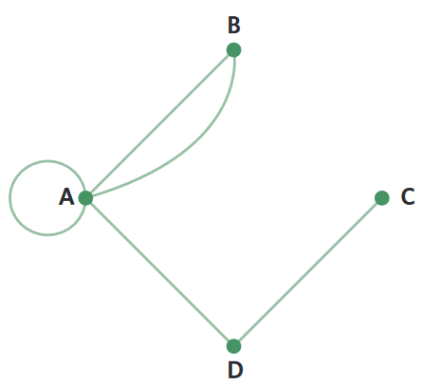

A vertex is point on the graph, represents an object | An edge is line drawn between vertices, represents a connection | 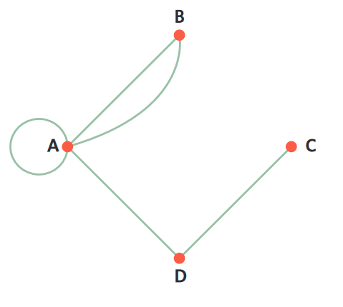  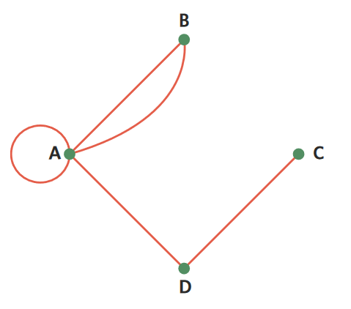  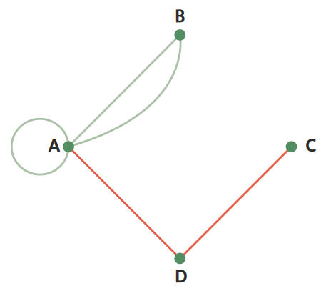  A vertex’s degree is the number of edges connected to it.

- Identify Real-life networks
For each network, identify what the vertices and edges represent.
Social networks  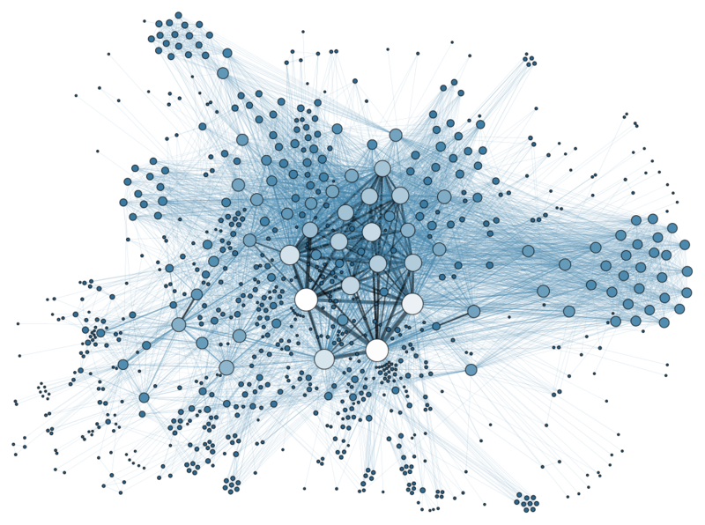  Vertex: ………………………  Edge: ……………………… | 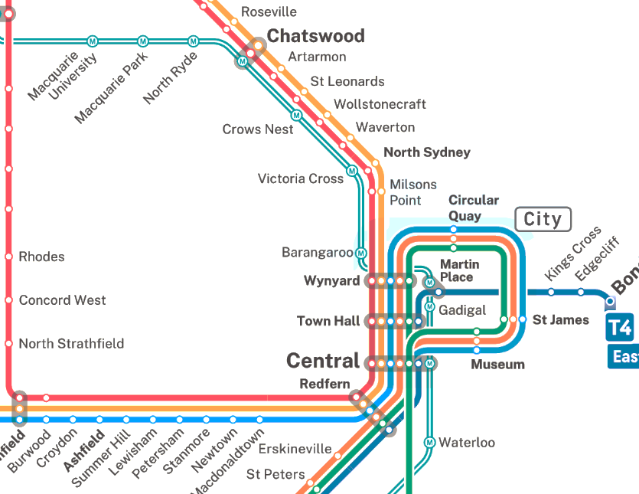  Transport networks  Vertex: ………………………  Edge: ………………………
Chemical bonds  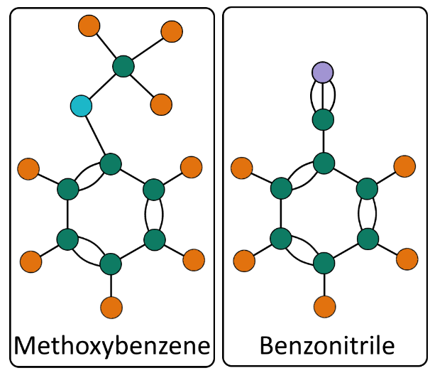  Vertex: ………………………  Edge: ……………………… | 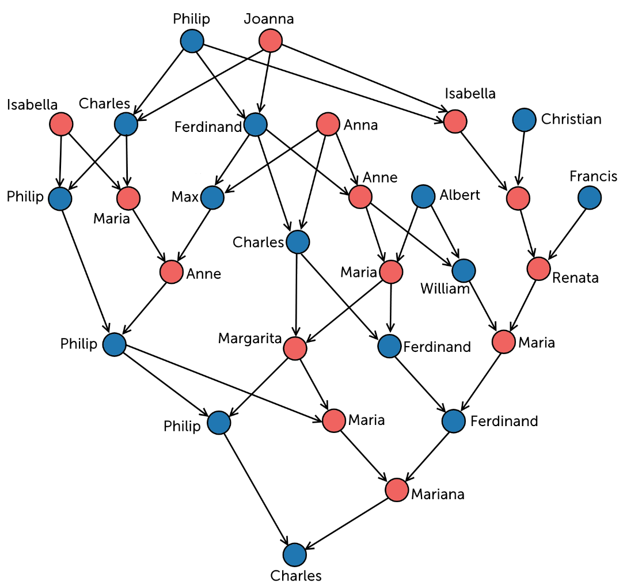  Family trees (Prince Charles II of Spain)  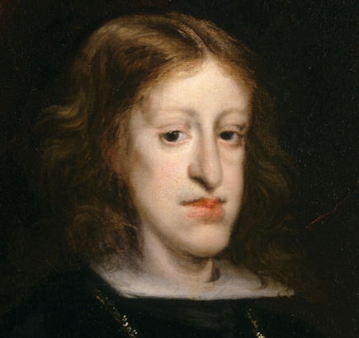  Vertex: ………………………  Edge: ………………………

- Language of Networks
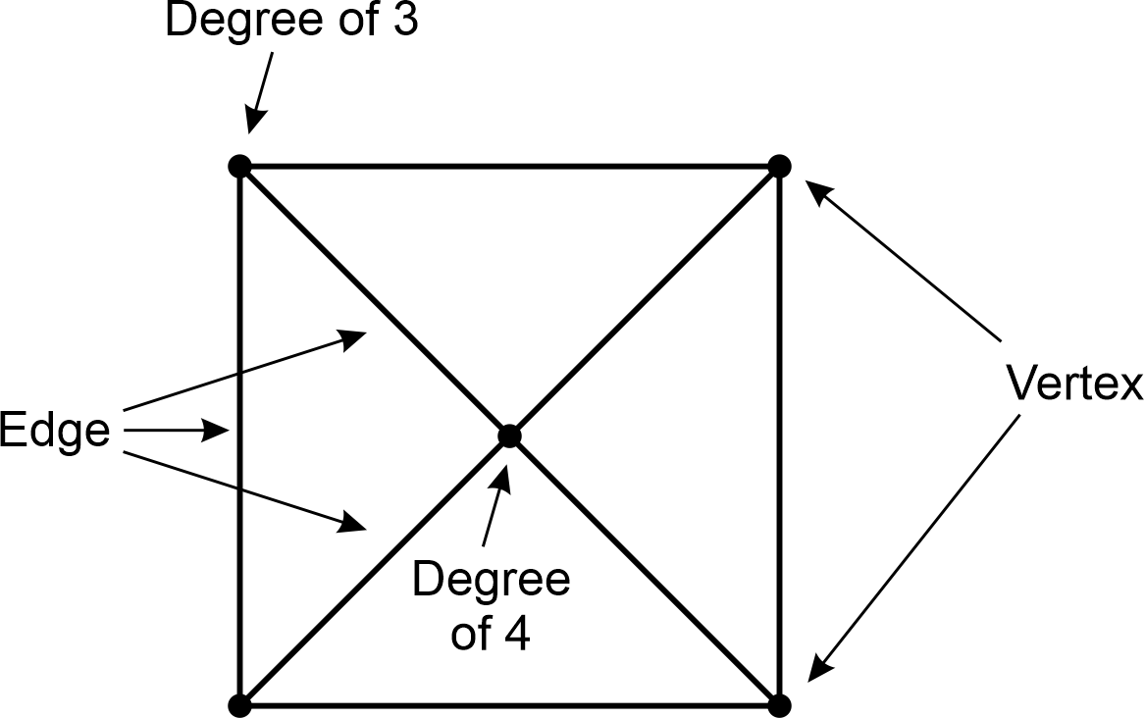

- Example Identify elements of a graph
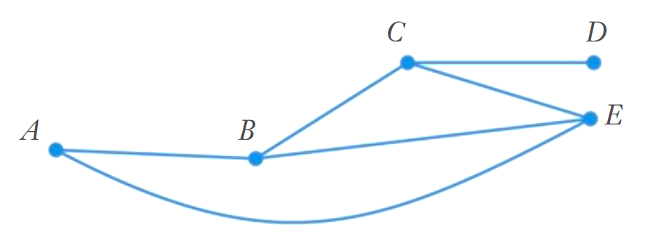
For the network diagram to the right:
Count the number of vertices. 5
Count the number of edges. 6
Identify the degree of each vertex.
d(A): 2 d(B): 3 d(C): 3 d(D): 1 d(E): 3

- Guided Practice
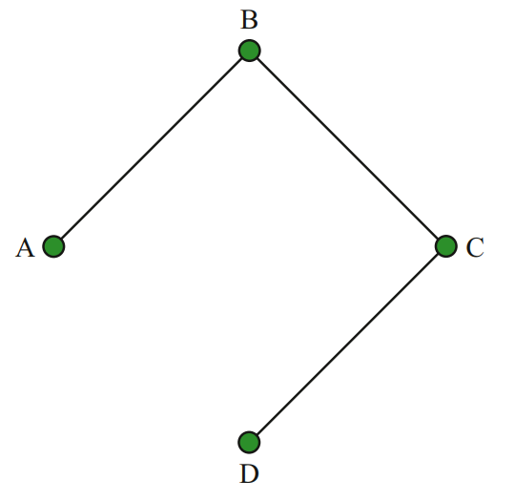  Vertices:  4  Edges:  3  Degree of vertices:  d(A): 1, d(B): 2, d(C), 2, d(D): 1 | 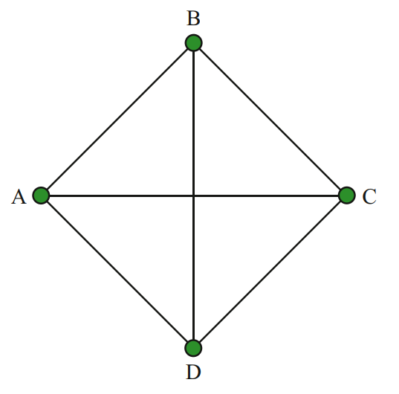  Vertices:  4  Edges:  6  Degree of vertices:  d(A): 3, d(B): 3, d(C), 3, d(D): 3 | 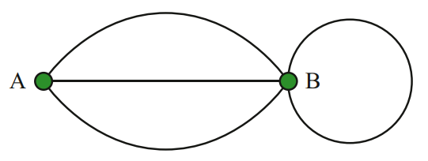  Vertices:  2  Edges:  4  Degree of vertices:  d(A): 3, d(B): 5

- Key Ideas
- A network describes a system of ………………………… objects.
- A simplified drawing of a network is called a ………………
- A ……………… is a point in a graph.
- Vertices are connected to each other by …………….
- The ……………… of a vertex is the number of edges that are connected to it.

Foundation
- For each graph, count the number of vertices, edges, and list the degree of each vertex.
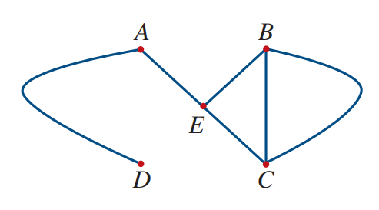  Vertices: ……………  Edges: ……………  Degree of vertices:  d(A): …………  d(B): …………  d(C): …………  d(D): …………  d(E): ………… | 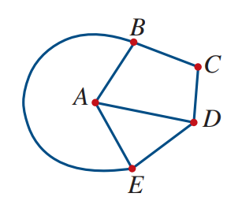  Vertices: ……………  Edges: ……………  Degree of vertices: | 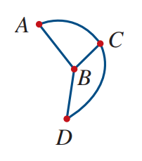  Vertices: ……………  Edges: ……………  Degree of vertices:

- This diagram shows the flight paths between capital cities in Australia.
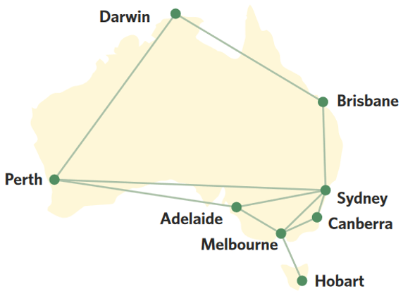
  - What do vertices represent?

  - What do edges represent?

  - What is the total number of flight paths?

  - How many flights are available from Sydney?

  - What does the degree of a vertex represent?

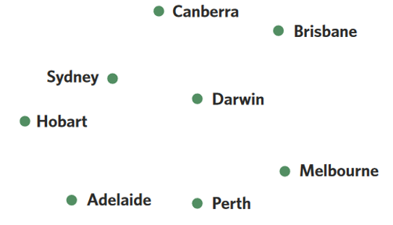
  - Determine the sum of the degrees of the vertices.

  - In a million years, the capital cities would have
moved due to plate tectonics.
Draw the same flight paths onto these vertices.

- A new fitness app allows users to connect with each other to share their fitness goals. When two people connect, they are called squadmates. The connections are shown on the graph.
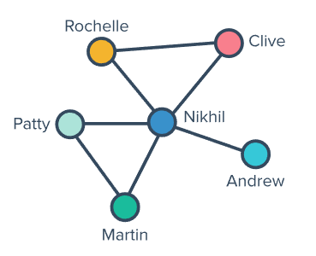
  - Who has the most squadmates?

  - Who has the least squadmates?

  - Are Rochelle and Patty squadmates?

- How many vertices of odd degree does this network have?
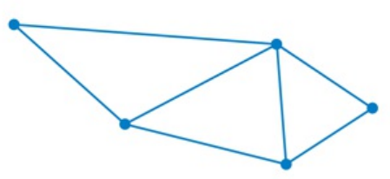

- How many vertices of even degree does this network have?
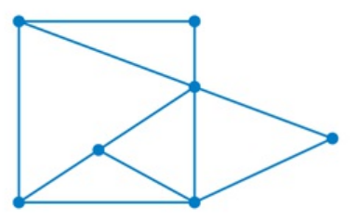

- Which network diagram represents this map showing the roads linking four towns?
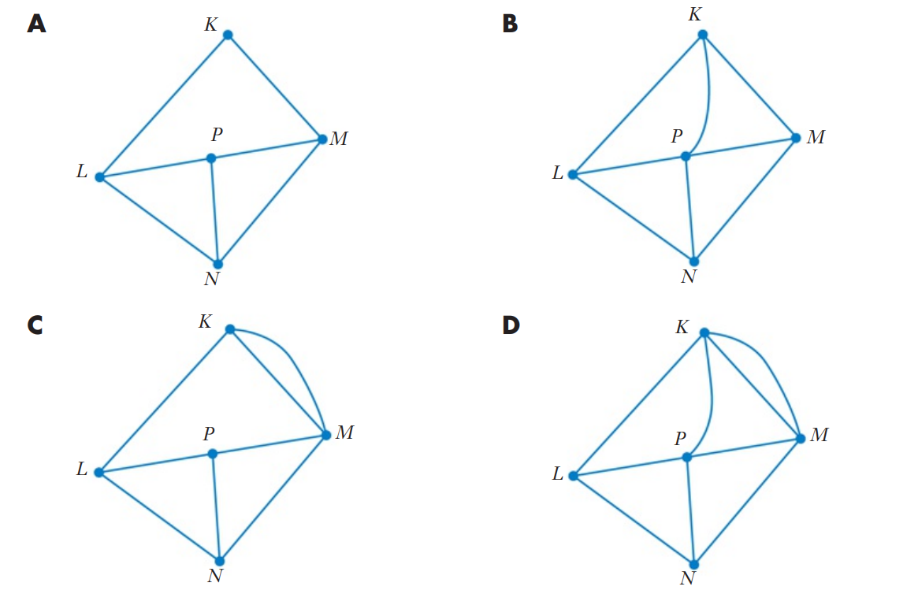
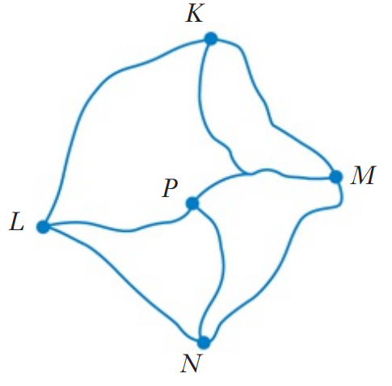

Development
- The network diagram on the left shows how rooms A, B, and C are connected.
Use the network diagram on the right to identify the rooms A, B, C and D
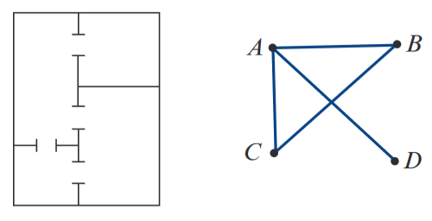
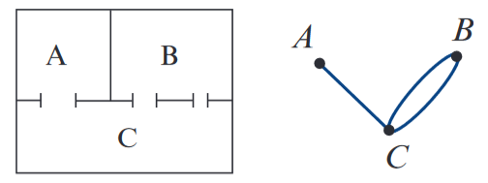

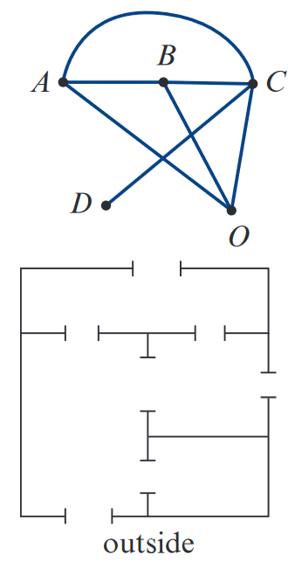
The network diagram below represents connections between four rooms and the outside (O).
Use the information to identify which rooms are A, B, C and D.

- The diagram shows a floor plan of a house.
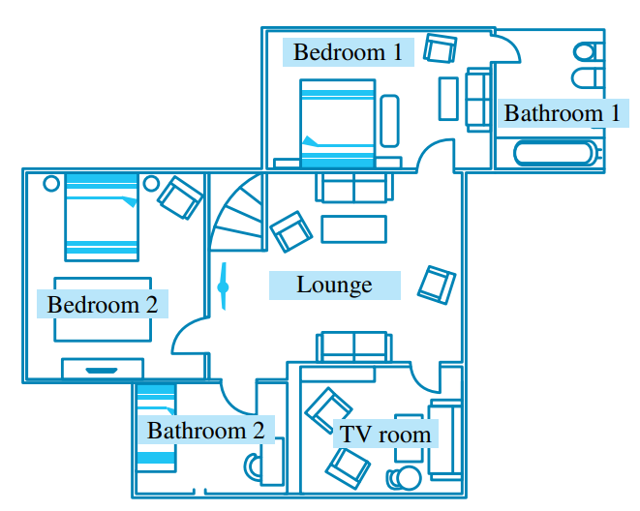
  - Draw a network to represent the possible ways of travelling between each room.

  - Which room has the highest degree?
  - Why would it be poor design to build a house with a bedroom of highest degree?

- What is the sum of the degrees of all the vertices in each of these networks?
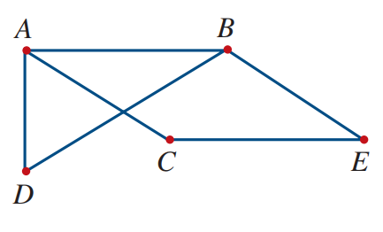 | 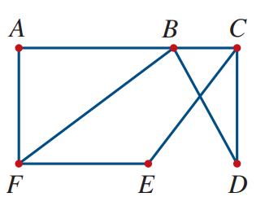 | 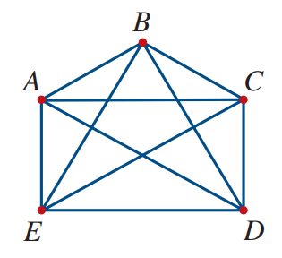

- 2021 HSC Standard 2 Band 4
What is the sum of the degrees of all the vertices in this network?
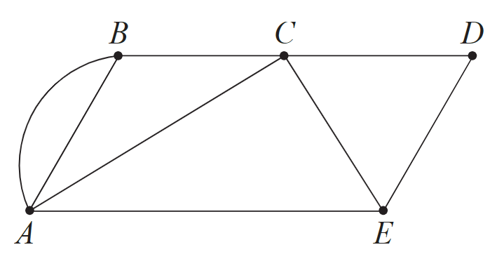

- 2011 VCE Band 4
In the network shown, the number of vertices of even degree is
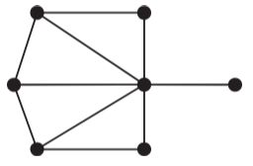

- 2020 HSC Standard 2 Band 5
Two chess teams enter a competition. The two teams have three members each. Each member of one team must play each member of another team once only. Which network diagram could represent the chess games to be played?
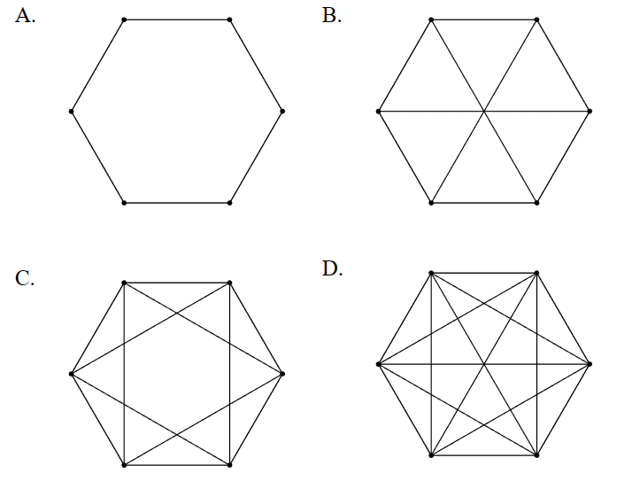

Mastery
- HSC Sample Question Band 5
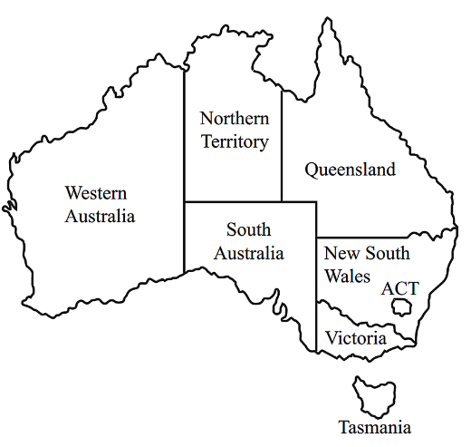
The map of Australia shows the six states and two territories, represented by the network diagram. The edges represent shared borders between two states/territories.

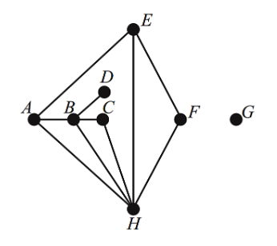

What is the order (degree) of the vertex that represents ACT?
Identify the letter representing Queensland. Explain why.

- 2009 VCE Band 6
A graph has five vertices.
Three of these vertices are of even degree and two of these vertices are of odd degree.
One extra edge is added. It joins two of the existing vertices.
In the resulting graph, it is not possible to have five vertices that are
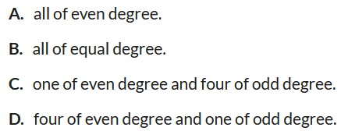

(hint: draw a possible network)

Weighted and Directed Graphs

- Weighted Graphs
- A weighted graph uses numbered edges.
- These numbers can represent many things, depending on the network’s context.

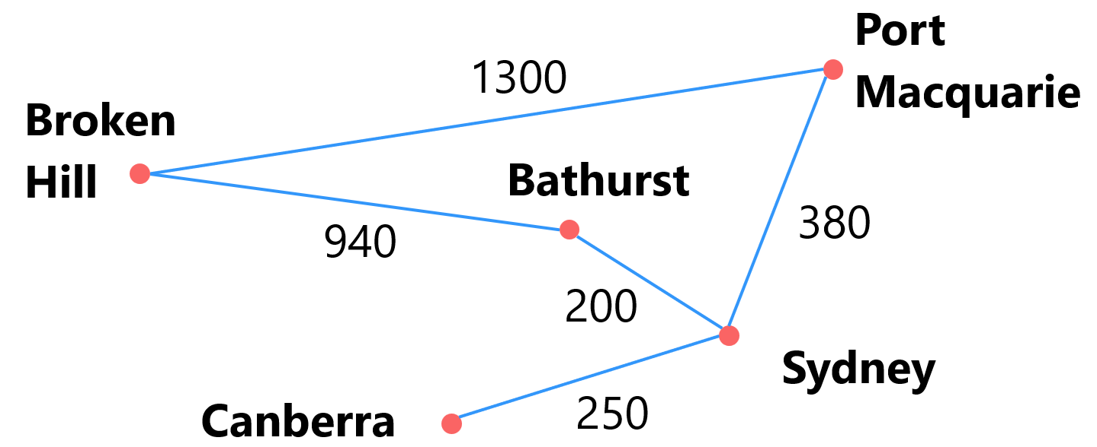

- Directed Graphs
- A directed graph uses arrows to show one-way relationships between vertices.
- Directed networks can include two-way connections.
Undirected Network | Directed Network
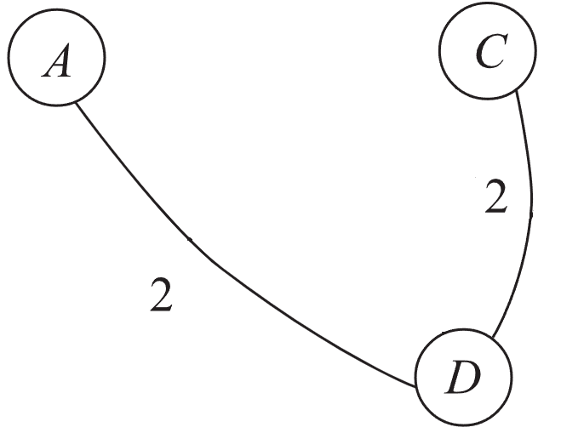 | 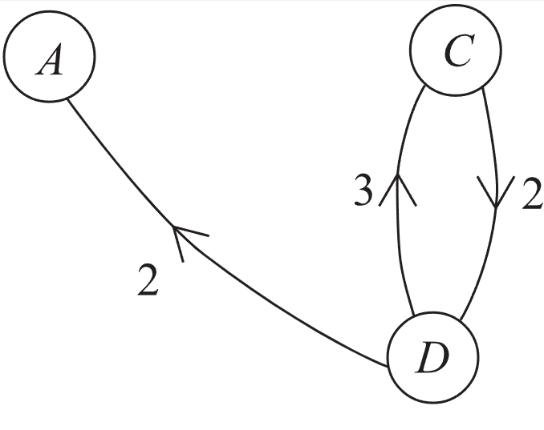  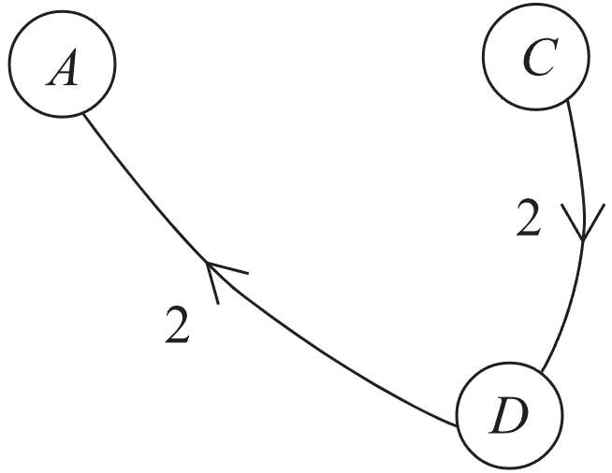
Examples of directed networks include:
- Road networks with one-way roads.
- Food chains
- Twitter followers.
- Electronic circuits.
- Scenarios involving flow of fluid.
- Links on the internet.

- Adjacency Matrix
- A network diagram can be shown as a table, called an adjacency matrix.
- The vertices are the row and column headings.
- Blank cells mean no direct connection between vertices.
- Cell values show the weight of edges.

- Guided Practice
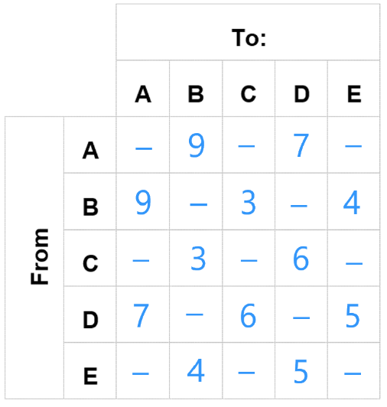
Convert this graph to a table.
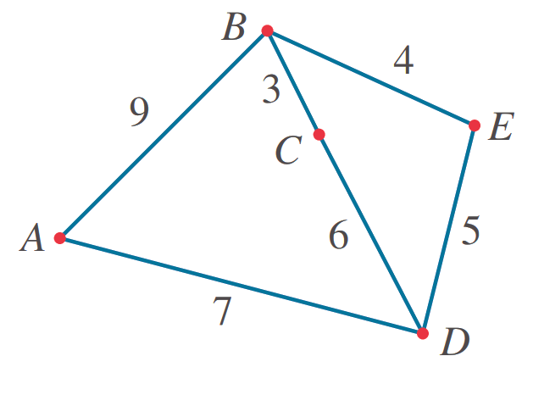

How do you know what the headings of the table will be?

Why is the table symmetrical along the diagonal?

Will the tables always be symmetrical?

- Guided Practice
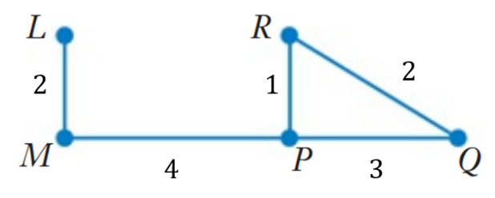
   |  | To:
   |  | L | M | P | Q | R
  From: | L | - | 2 | - | - | -
  From: | M | 2 | - | 4 | - | -
  From: | P | - | 4 | - | 3 | 1
  From: | Q | - | - | 3 | - | 2
  From: | R | - | - | 1 | 2 | -
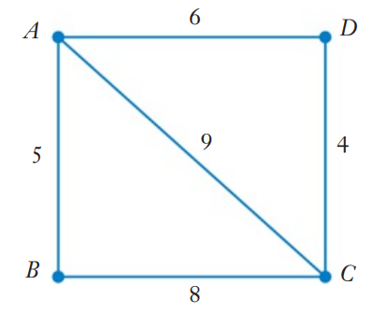
   |  | To:
   |  | A | B | C | D
  From: | A | - | 5 | 9 | 6
  From: | B | 5 | - | 8 | -
  From: | C | 9 | 8 | - | 4
  From: | D | 6 | - | 4 | -
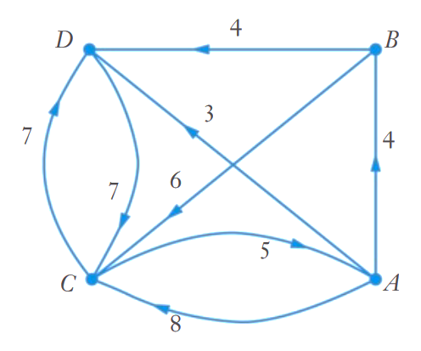
   |  | To:
   |  | A | B | C | D
  From: | A | - | 4 | 8 | 3
  From: | B | - | - | 6 | 4
  From: | C | 5 | - | - | 7
  From: | D | - | - | 7 | -

Foundation
- Consider the graph below.
  - Represent this graph using a table.
 |  | To:
 |  | W | X | Y | Z
From: | W
From: | X
From: | Y
From: | Z
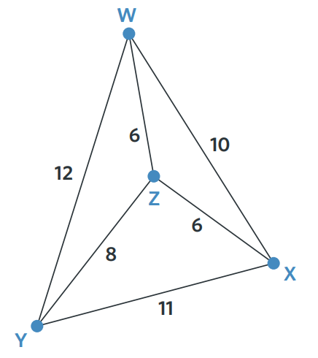

  - Explain why the table is symmetrical along the diagonal.

- Construct a directed graph from these tables.

 |  | To:
 |  | A | B | C | D
From: | A | - | 2 | 3 | 1
From: | B | - | - | - | 3
From: | C | - | 2 | - | -
From: | D | - | - | - | -

 |  | To:
 |  | A | B | C | D
From: | A | - | - | 2 | 5
From: | B | 1 | - | 7 | -
From: | C | - | - | - | 4
From: | D | - | 3 | - | -

Development
- The table lists the number of likes 3 friends give to each other’s social media posts over a week.
 |  | To:
 |  | Keira | Charlotte | Willa
From: | Keira | - | 32 | 12
From: | Charlotte | 6 | - | 9
From: | Willa | 41 | 53 | -

  - Explain why the table is not symmetrical along the diagonal.

  - Explain why the diagonal is blank within the context of the scenario.

- HSC Sample Question Band 4
The table below represents a directed network. Complete the network diagram below to represent the information in the table.
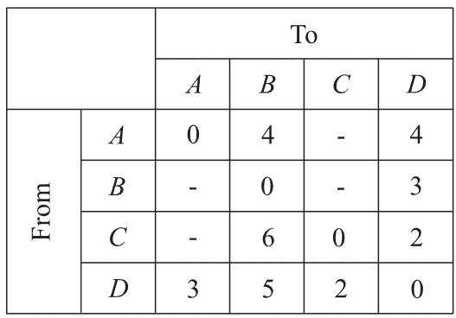
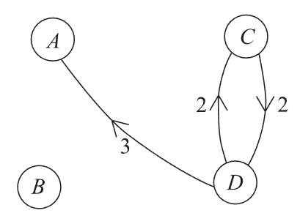

- HSC Sample Question Band 4
A directed network is shown below. Use it to complete the table.
“0” means that no connection exists.
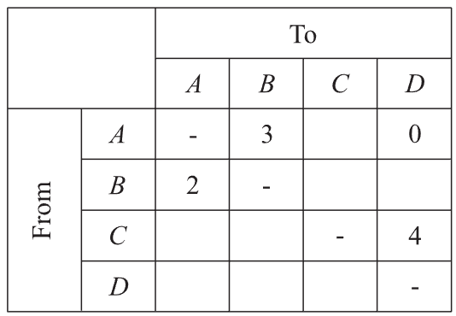
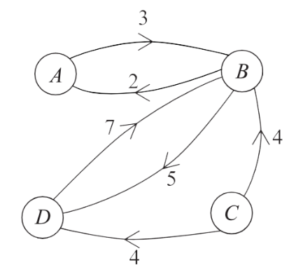

Walks and Paths

- Walks and Paths
- A walk is a journey through a graph. A walk:
- Starts at a vertex.
- Travels along edges.
- Ends at a vertex.
- A walk lists vertices in visit order.

- Example Describe walks using vertices
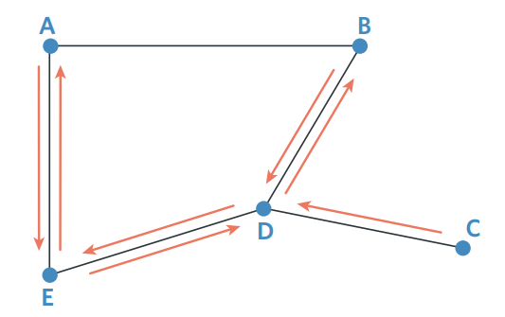
Describe the walk, starting from C.

C – D – B – D – E – A – E – D

- Guided Practice
Describe the walk.
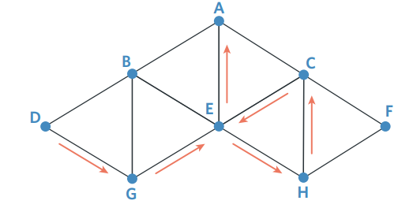  D – G E – H – C – E – A |  | 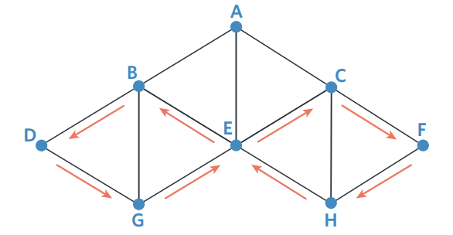  D – G – E – C – F – H – E – B – D
Show the walk on the diagram.
- G – D – E – G |  | 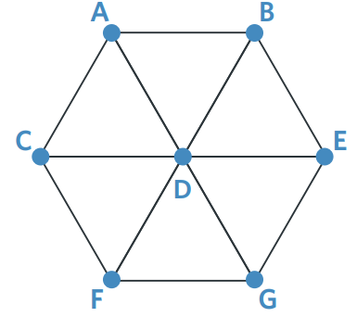  - C – D – E – B – D – G – E – D
- Types of Walks
- Walks are classified based on repeated edges/vertices and whether they are closed.
- A closed walk starts and ends at the same vertex.
- Paths are the only type of walk you need to know for the HSC Standard course.
Trail | Circuit | Path | Cycle
No repeated edges. | A closed trail. | No repeated edges.  No repeated vertices. | A closed path.  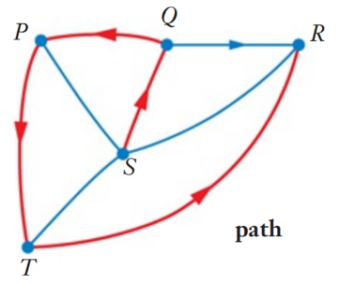  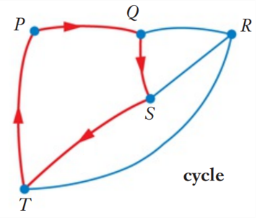  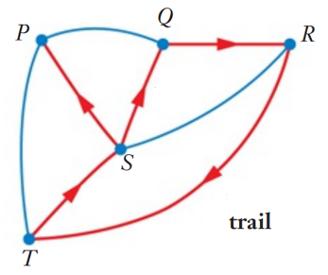  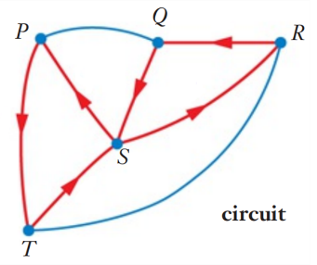

- Identify paths
Decide whether these are paths (A cycle is a type of path).
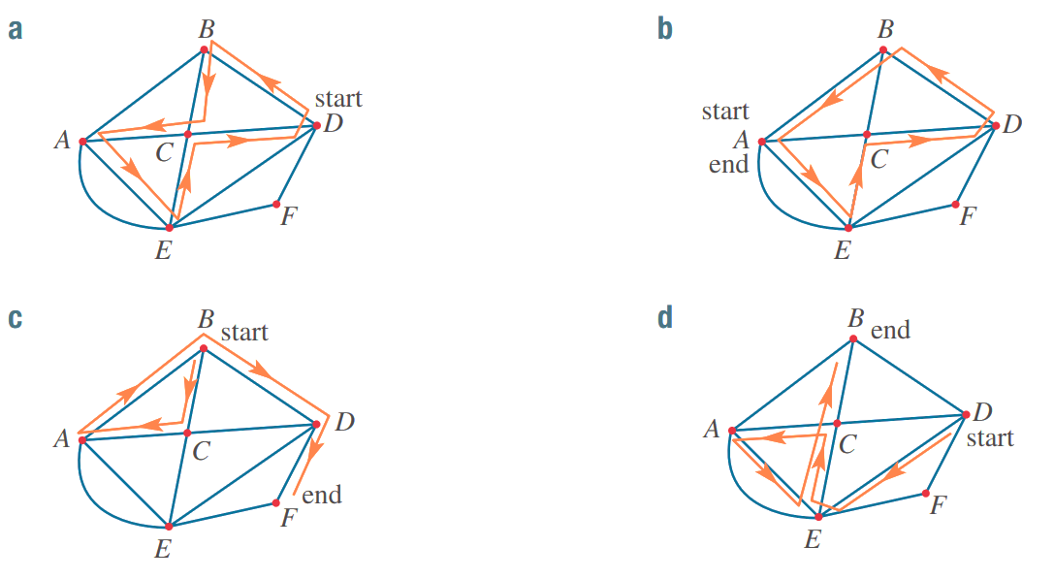

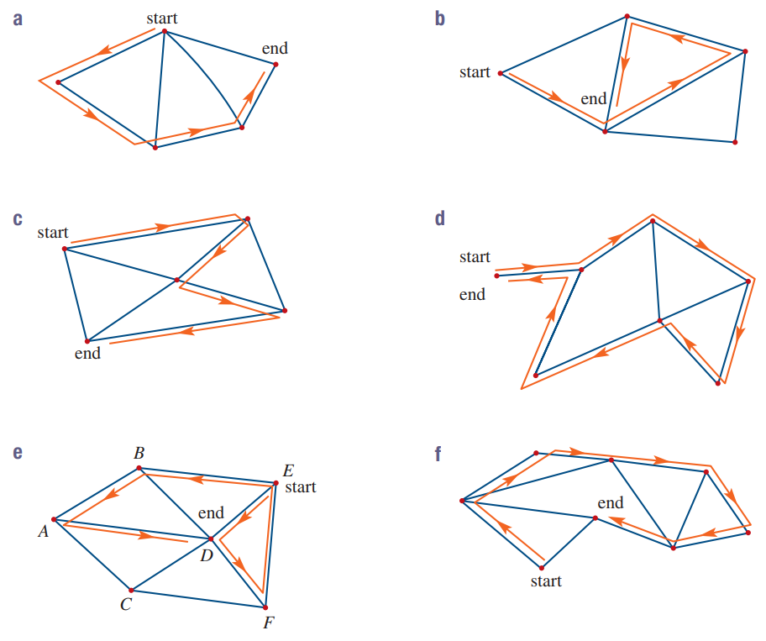

- Basic Networks Problems
Basic network problems involve:
- Interpreting the context of a network.
- Converting the network to a graph.
- Answering questions based on walks.

These may involve some amount of guessing and checking.

- Guided Practice
The train stations in Sydney CBD are called the City Circle.
On a particular day the trains are only running in one direction.
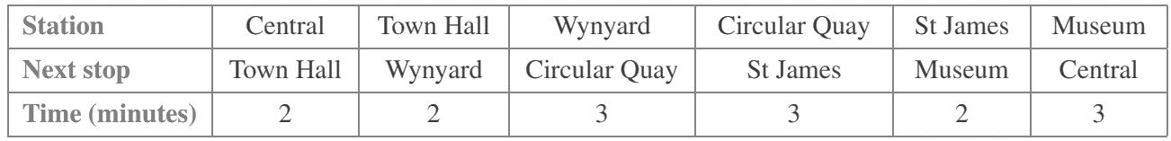

Represent this information as a graph:
Graph:
The vertices are:
The edges are:
The weights are:

How long does it take to travel from Central to
St James?

Foundation
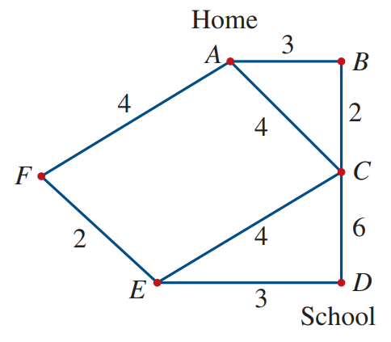
- This network diagram represents several streets for travel between home and school.
The numbers indicate travel time in minutes.
  - How long does it take to travel to school using these paths?
    - A F E D
    - A F E C D
    - A C D
    - A B C D
    - A C E D
  - Which of the above walks is the longest journey?
  - Which of the above walks is the shortest journey?

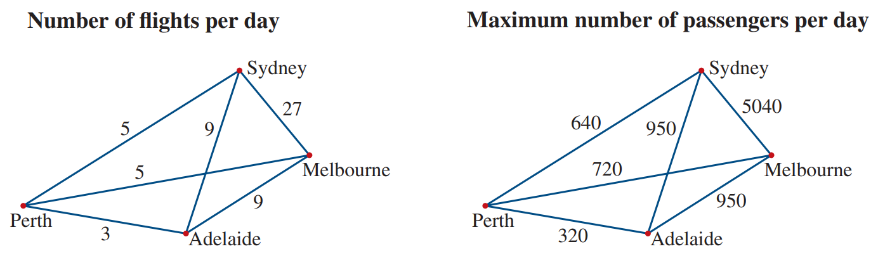
- The graphs below show details about air travel between Australian cities.

  - How many flights are available per day between Sydney and Adelaide?
  - How many total flights are available between all these cities?
  - What is the maximum passengers per day that can fly out of Sydney?

- A route through the following weighted graph has a total weight of 20.
What could the route be?
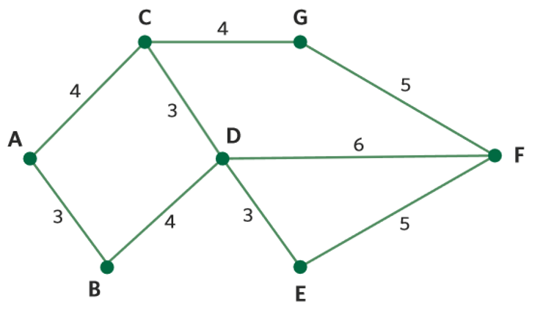

- A B D C G F | - A C D E F G | - B D F E D | - G F D E F

Development
- The following graph shows the distance between five country towns in kilometres.
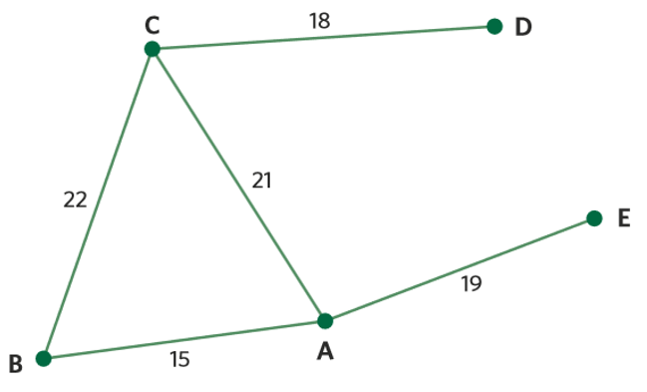
What are the distances of the paths between:
  - C to D ……………
  - E to A to C ……………
  - B to C to A to E ……………

- This weighted graph shows the time taken to walk between five locations, in minutes.
If it takes 59 minutes to walk the path D A B E, what is the value of $x$?
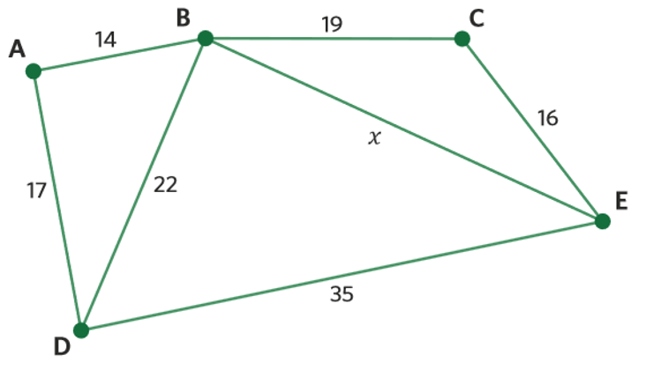

- Bailey is on holiday in Timboon and wants to visit a few nearby towns.
If the numbers represent the distance between towns in kilometres, what is the distance of the path that starts at Timboon, travels through each town once and ends at Kennedy’s Creek?
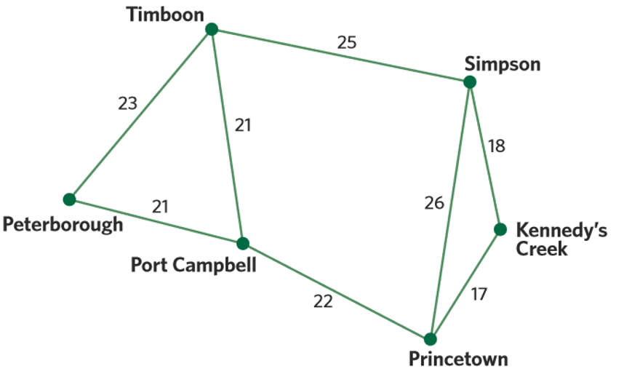

Mastery
- The network diagram below models forest walkways connecting a bridge (B), waterfall (W), a big tree (T) and a fern gully (F). Walkers enter the forest through gate 1 (G1) or gate 2 (G2).
The edge weights represent time taken to walk directly between these places.
To:
From:
  - Represent graph as a table.
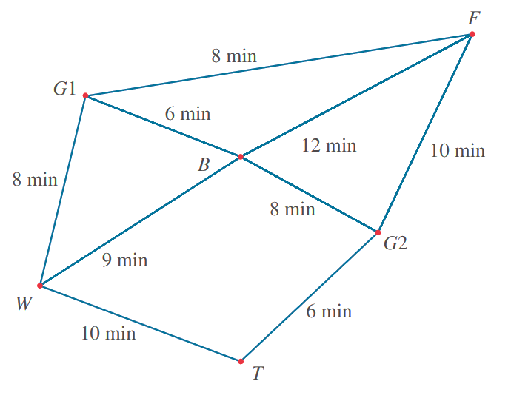

  - A tourist walks from the tree to fern gully via the waterfall and bridge.
    - How long did it take?
    - A faster walk that goes from the tree to fern gully is possible. Identify it.

  - A tourist undertakes the walk G1 W B F G2 B G1. How long did it take?

- HSC Sample Question Band 4
In central Queensland, there are four petrol stations A, B, C and D.
The table shows the length, in kilometres, of roads connecting these petrol stations.
Construct a network diagram to represent this information.
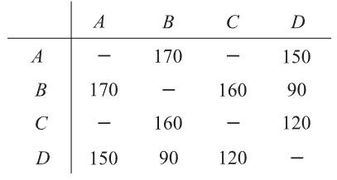

A petrol tanker needs to refill each station. It starts at station A and visits each station. Determine the shortest path and distance that can be travelled by the petrol tanker.

Trees and Spanning Trees

- Connected Graphs
In a connected graph, you can move from any vertex to any other by following edges.

- Identify connected graphs
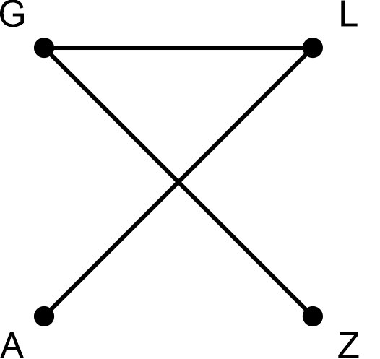 | 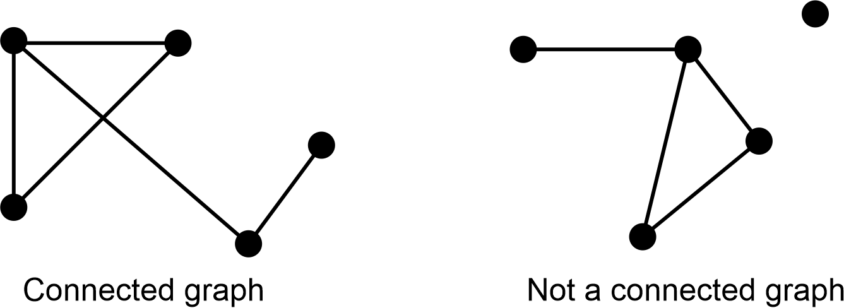
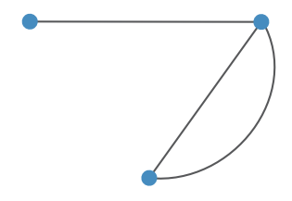 | 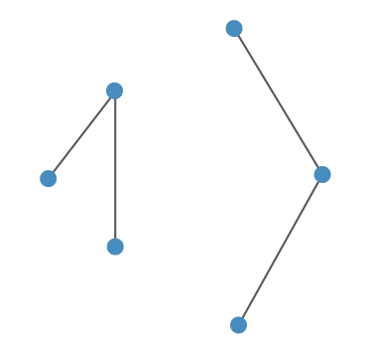 | 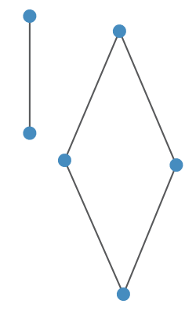
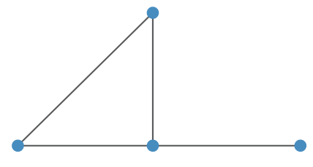 | 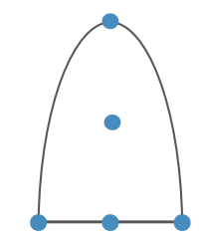 | 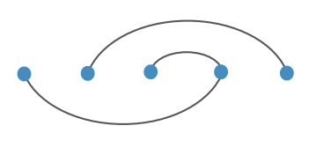

- Trees
- A tree is a connected graph with only one path between any two vertices
- Reminder: a path is a walk without repeated vertices or edges.
- A tree with $n$ vertices always has $\left(n-1\right)$ edges.
- A tree has no loops, multiple edges, or cycles.
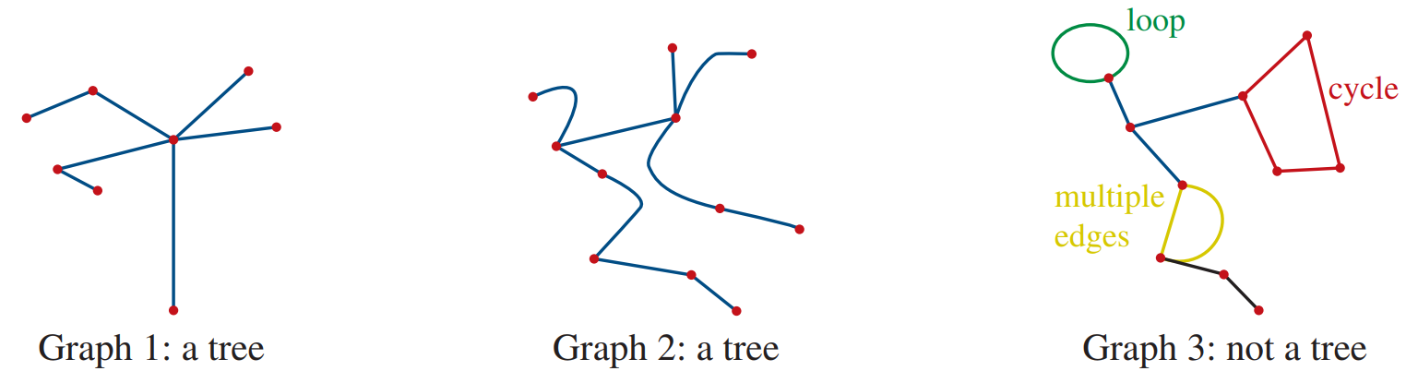

- Identify trees
yes | no | 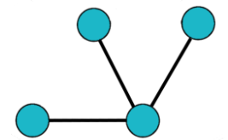  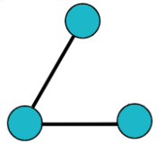  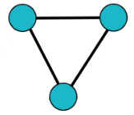  yes
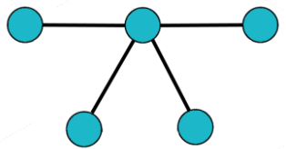  yes | 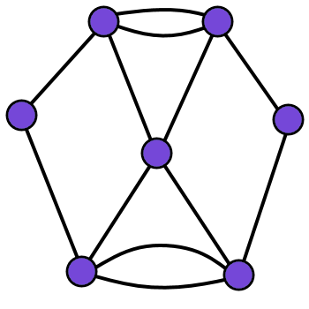  no | 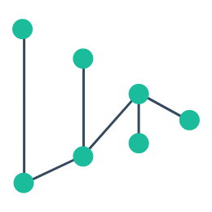  yes
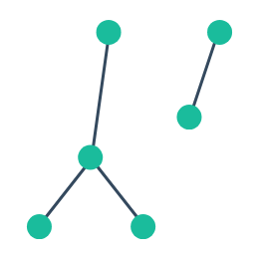  no | 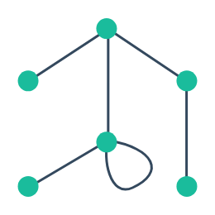  no | 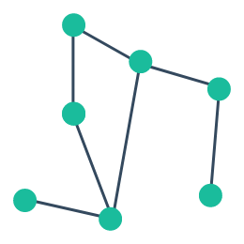  no

- Spanning Trees
- A spanning tree connects all the vertices of the original graph with the fewest edges.
- A spanning tree connects all vertices with the least edges.
- To find a spanning tree:
  - Count the total vertices $n$.
  - Remove edges until $\left(n-1\right)$ edges remain.
    - First, remove edges from loops and duplicate edges.
    - Remove edges from cycles, keep all vertices connected.
- There can be more than one way to create a spanning tree.

- Example Construct a spanning tree
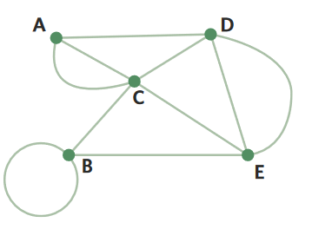
Construct a spanning tree of this graph.

1. There are 5 vertices, so the spanning tree has max 4 edges.
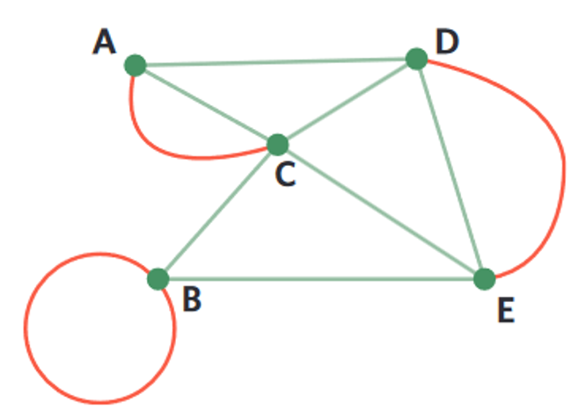
2a. Remove edges from loops and cycles. 2b. Remove edges from cycles.
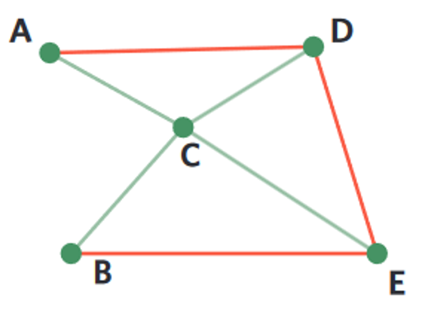

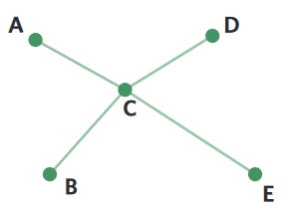
Final spanning tree:

- Guided Practice
Create a spanning tree from these graphs
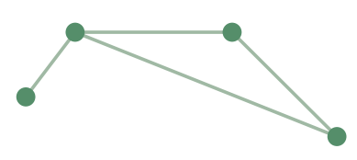 | 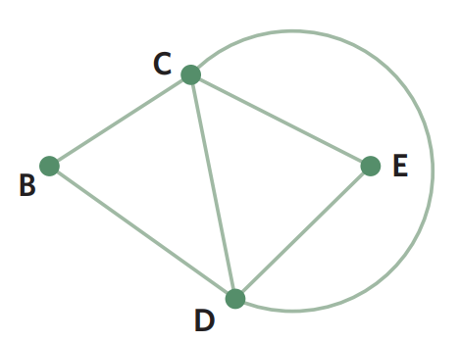
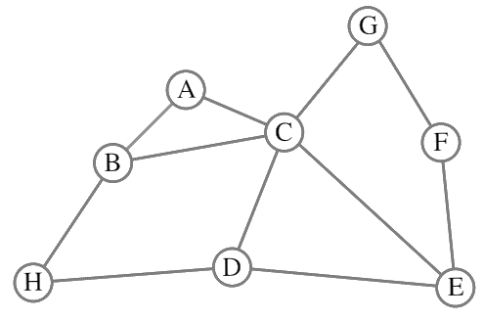 | 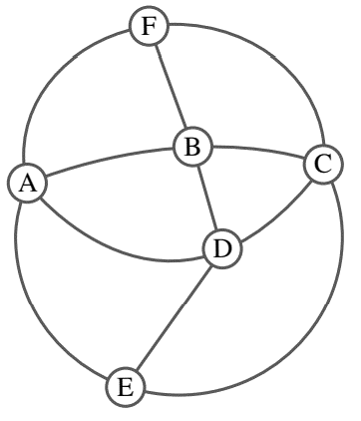

- Key Ideas
- A tree has only one …………… connecting any two vertices.
- A tree has no ……………, ……………………… ……………, nor ………………… and always has 1 less …………… compared to the number of vertices.
- For a given graph, a spanning tree is a graph that connects all …………………… with the least edges.

Foundation
- A tree has seven vertices. How many edges does it have?
- A tree has seven edges. How many vertices does it have?
- Identify which of the following are trees.
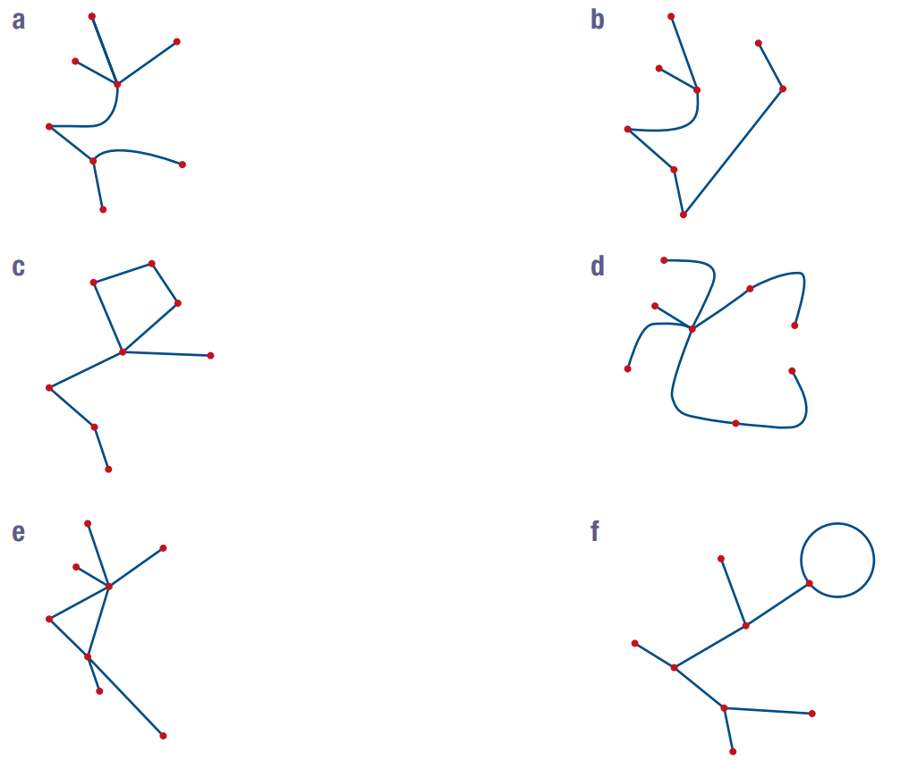

- Draw two different spanning trees for each of these graphs.
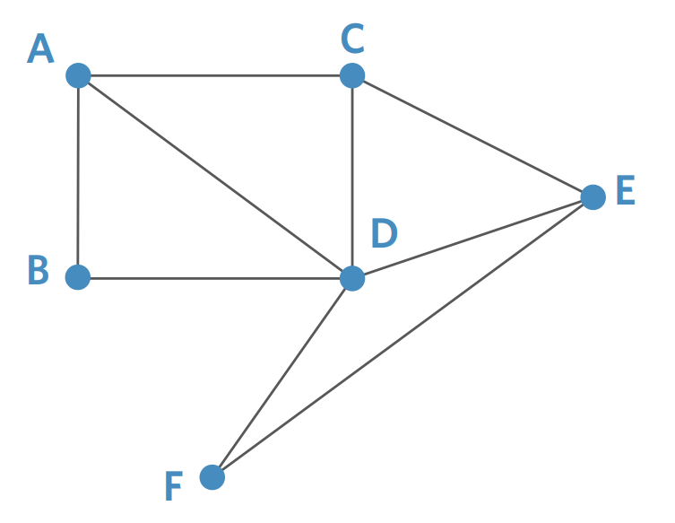
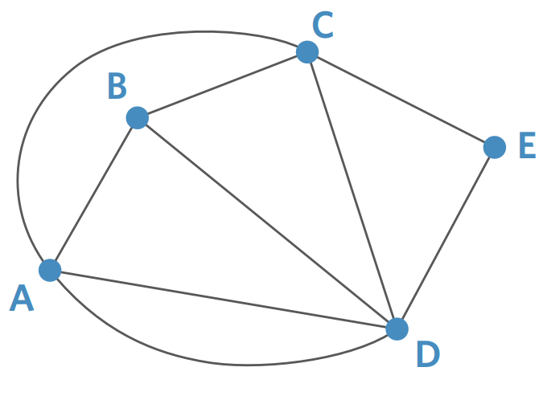

Development
- Construct a spanning tree for these networks.
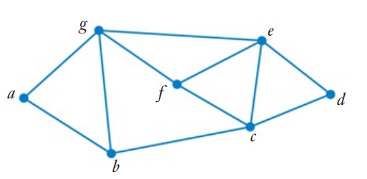

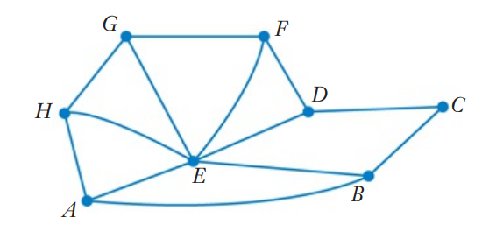
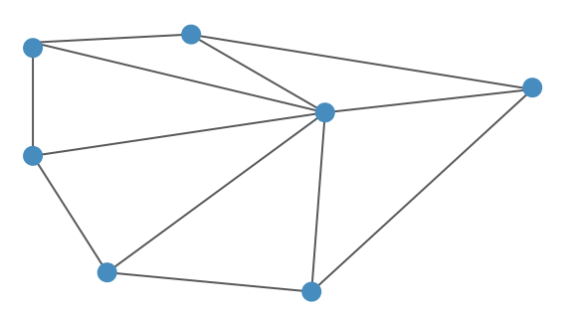
- Zoe the software engineer is setting up a computer network and is trying to connect all the computers using the least number of wires possible. The graph shows possible connections between computers.
  - What is the least number of wires Zoe can use?
……………………………………………………
  - Draw two possible layouts of the network.

- Edges were removed from the graph below so that it has the minimum number of edges to remain connected. How many edges were removed?
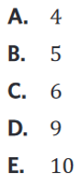
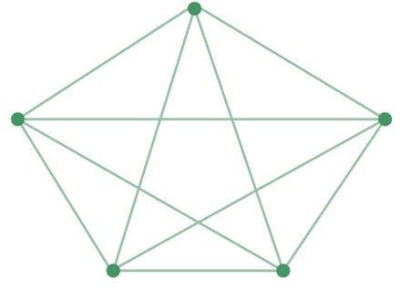

C

Minimum Spanning Trees

- Construct a Minimum Spanning Tree
- A minimum spanning tree connects all vertices with lowest total edge weight.
- Prim’s Algorithm finds a minimum spanning tree.
- Pick any vertex to start.
- Choose the lowest edge weight from this vertex and draw the connection.
- From all existing tree vertices, choose the edge with the lowest weight.
- Repeat step 3 until all vertices connect.

- Example Construct a minimum spanning tree
Find the minimum spanning tree.

Step 1: Choose A Step 2: Connect AB Step 3: Connect AD
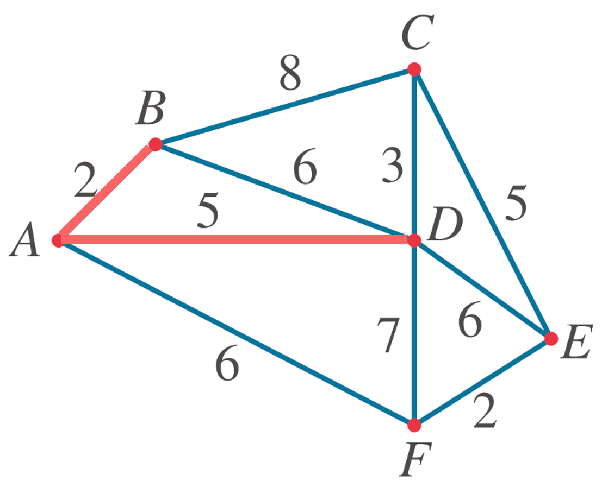
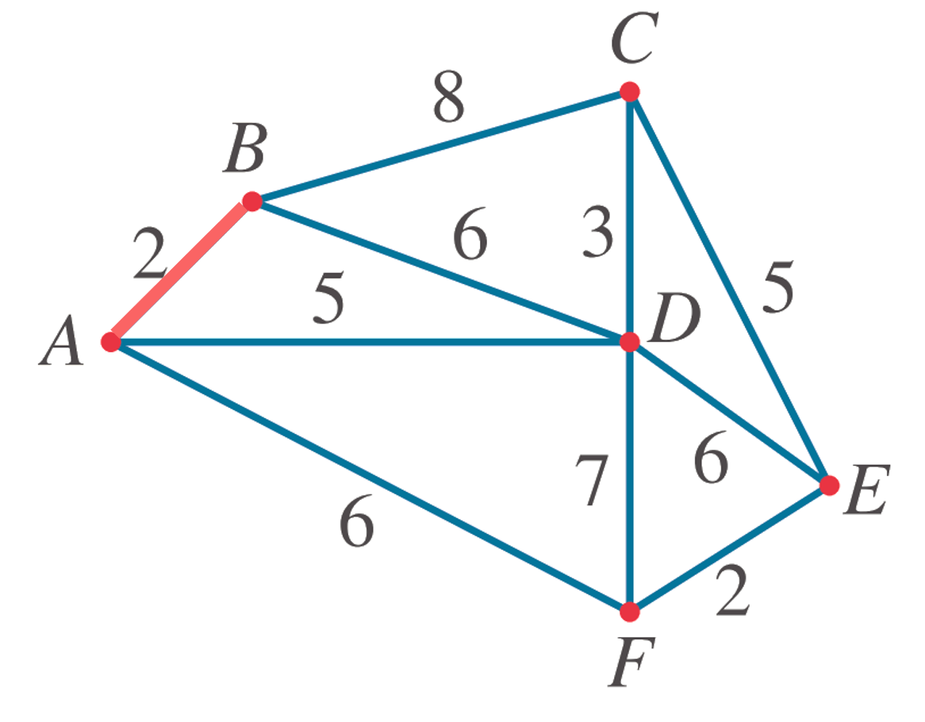
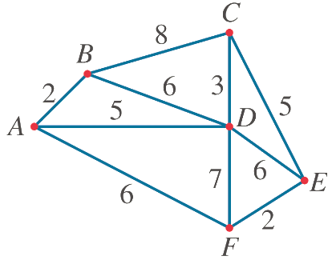

Step 4: Connect DC Step 4: Connect CE Step 5: Connect EF
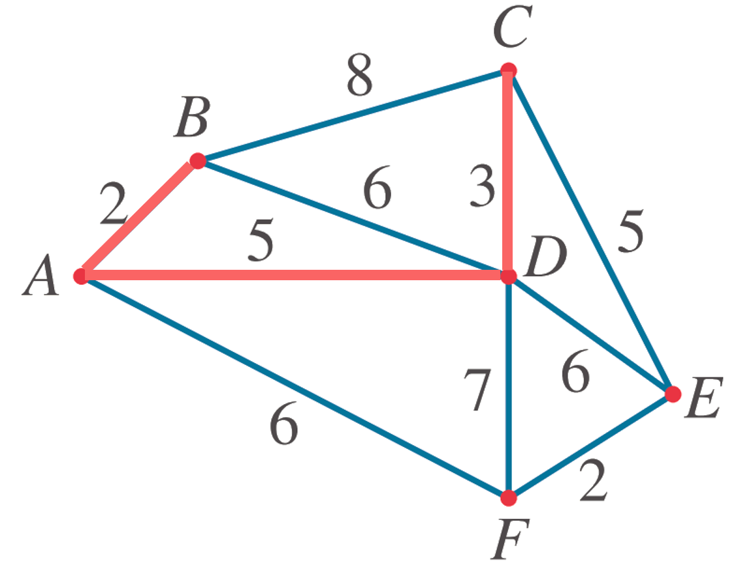
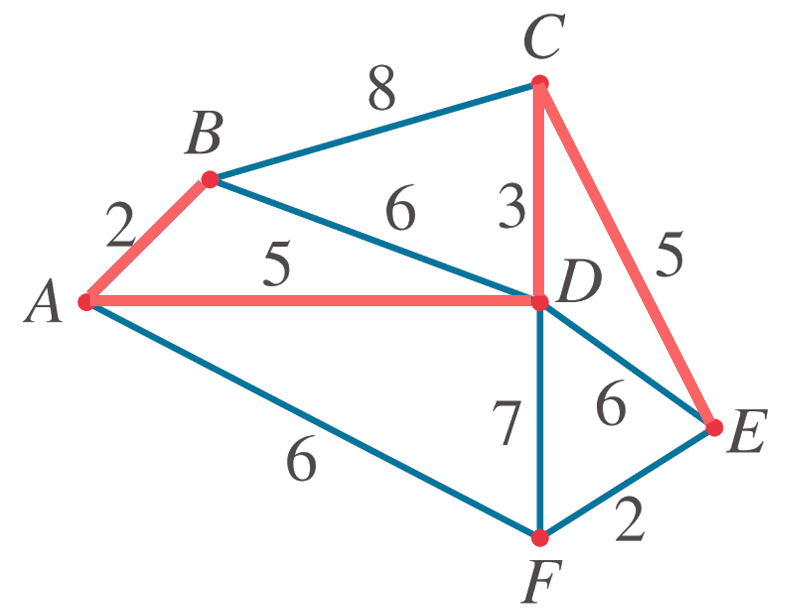
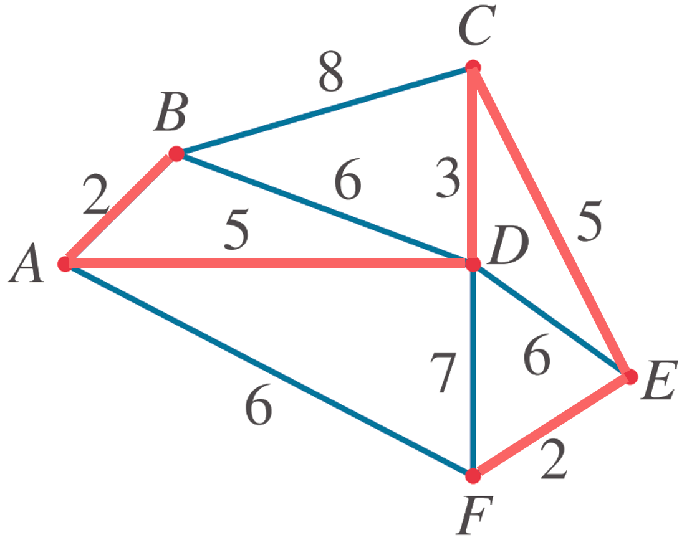

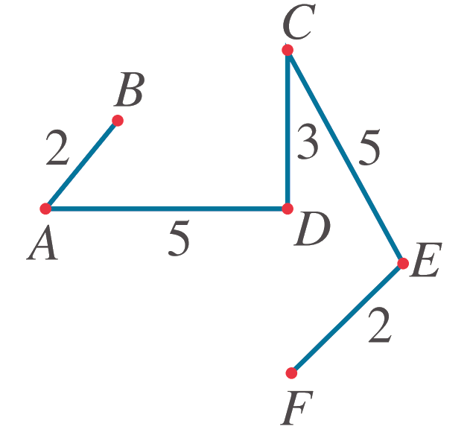
Minimum spanning tree, with length 17:

In step 3, why was AD connected and not BD?

- Guided Practice
Construct the minimum spanning tree and state the sum of the edge weights of the tree.
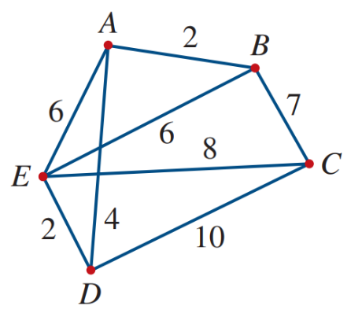

15
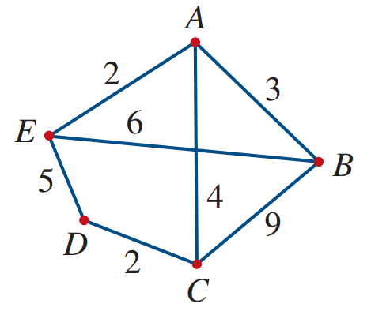

11
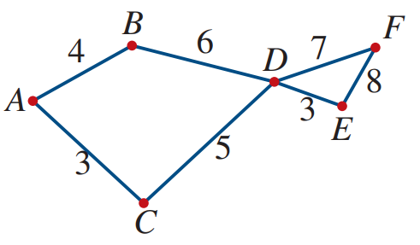

22

Foundation
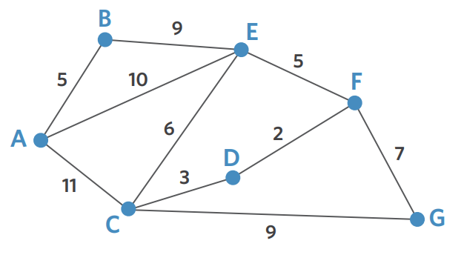
- The weight of the minimum spanning tree for the graph is 31.
Draw the minimum spanning tree.

- Construct the minimum spanning tree and calculate their weights.
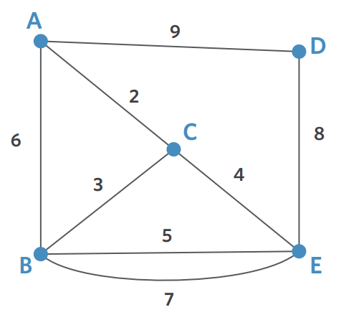 | 17
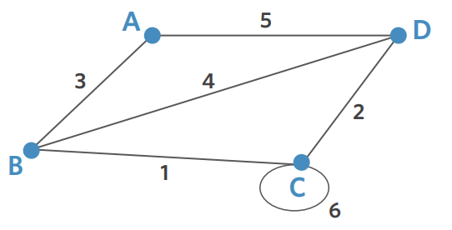 | 6
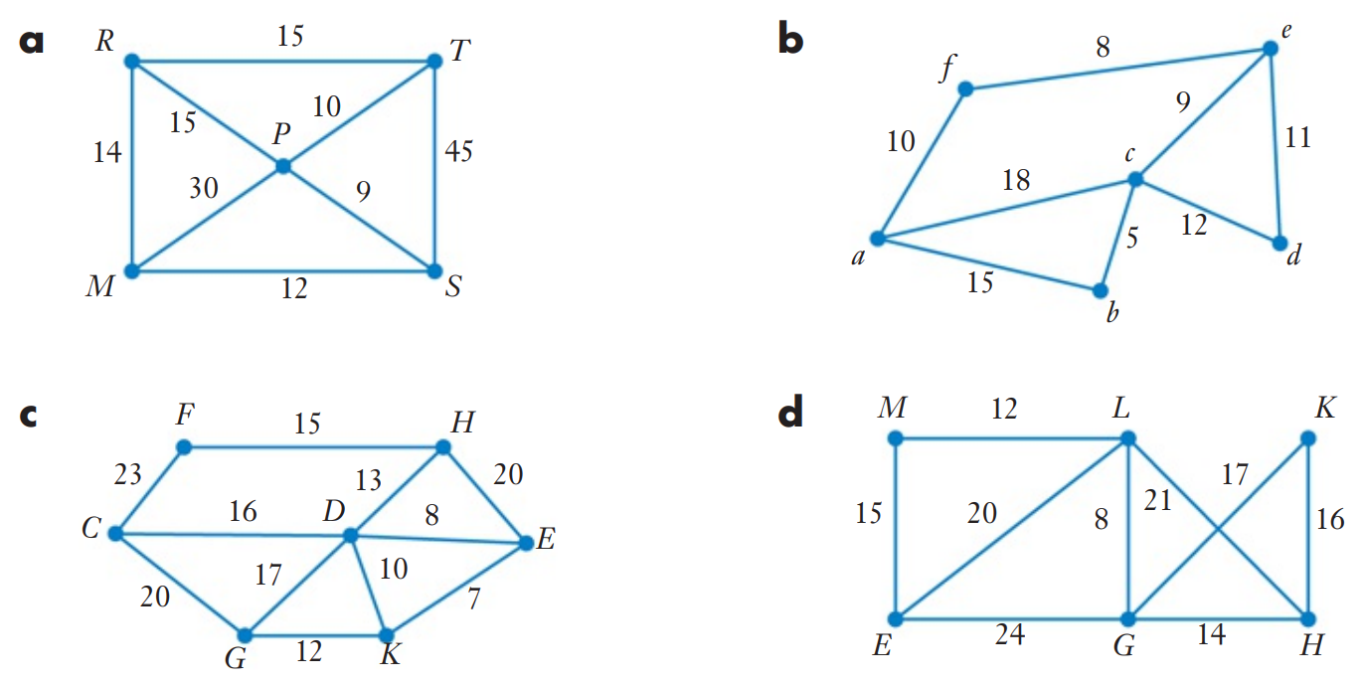 | 45
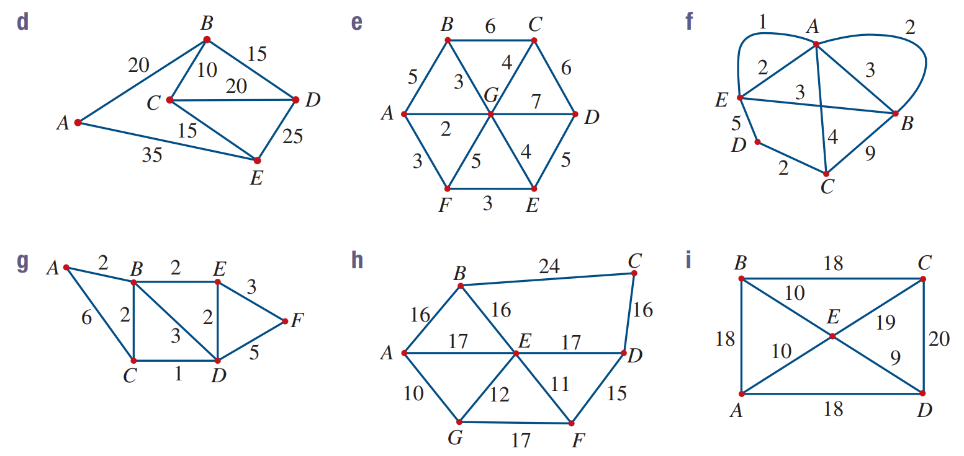 | 10
 | 9
 | 65
 | 60
 | 20

Development
- The minimum spanning tree for the network includes 2 edges with weighting $a$ and $b$.
The length of the minimum spanning tree is 25. What are the values of $a$ and $b$?
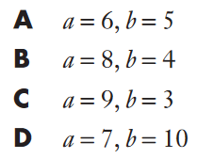
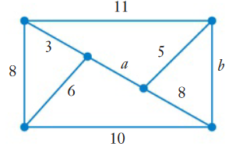

A
- HSC Sample Question Band 3
The diagram below is a connected network.
Complete the diagram to show the how all vertices can be connected with least edge weights.
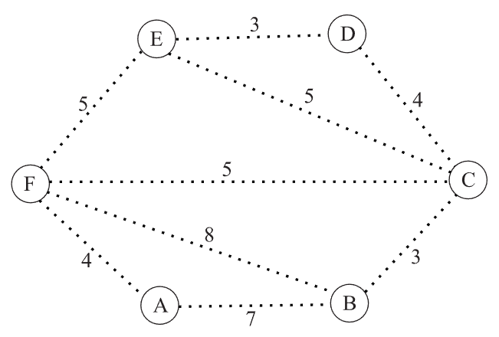
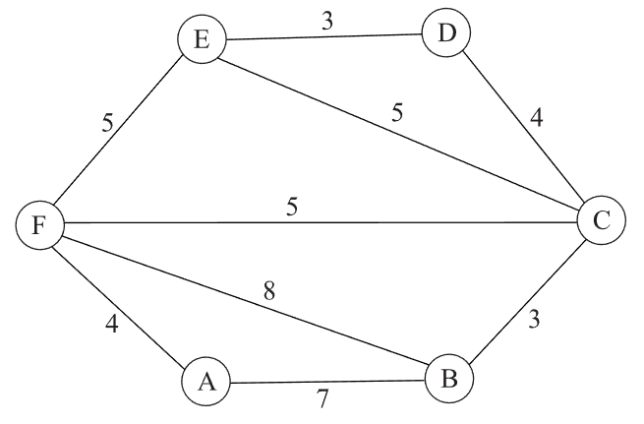

What is the mathematical term that describes the diagram you have produced?
………………………………………………………………………………………………………………

- 2016 VCE Band 5
The minimum spanning tree for the network below includes the edge with weight labelled $k$.
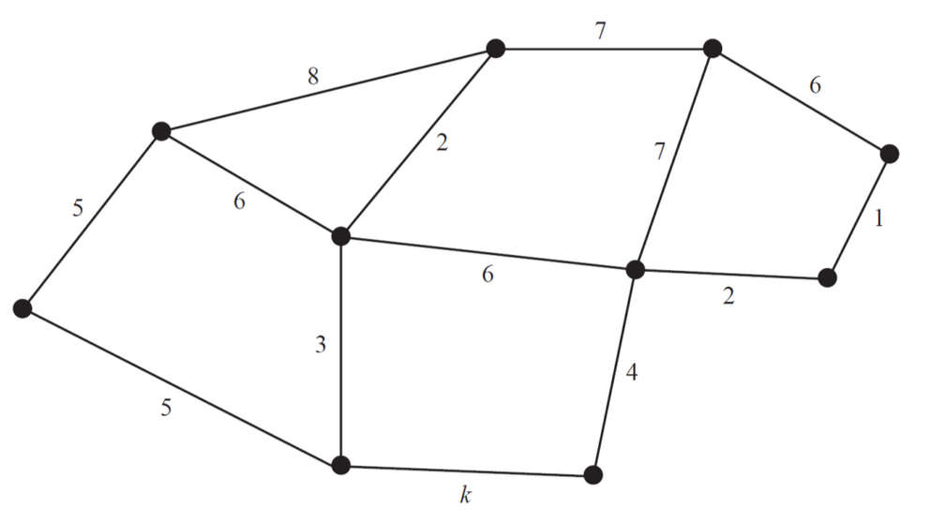
The total weight for all edges of the minimum spanning tree is 33.
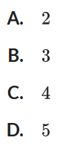
What is the value of $k$?

Minimal Connector Problems

- Minimal Connector Problem
- A minimum spanning tree links all vertices using the lowest edge weights.
- Minimal connector problems use minimum spanning trees to find the cheapest way to link real-world sites.

- Example Solve connector problems
The network diagram shows possible water pipes connecting six towns.
The numbers on each edge represent the distance between towns in kilometres.
Determine the shortest distance connecting water pipes to the six towns.
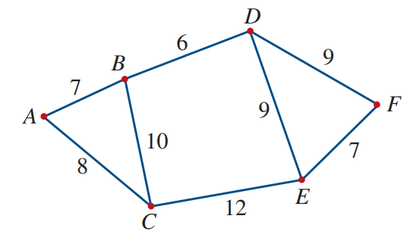
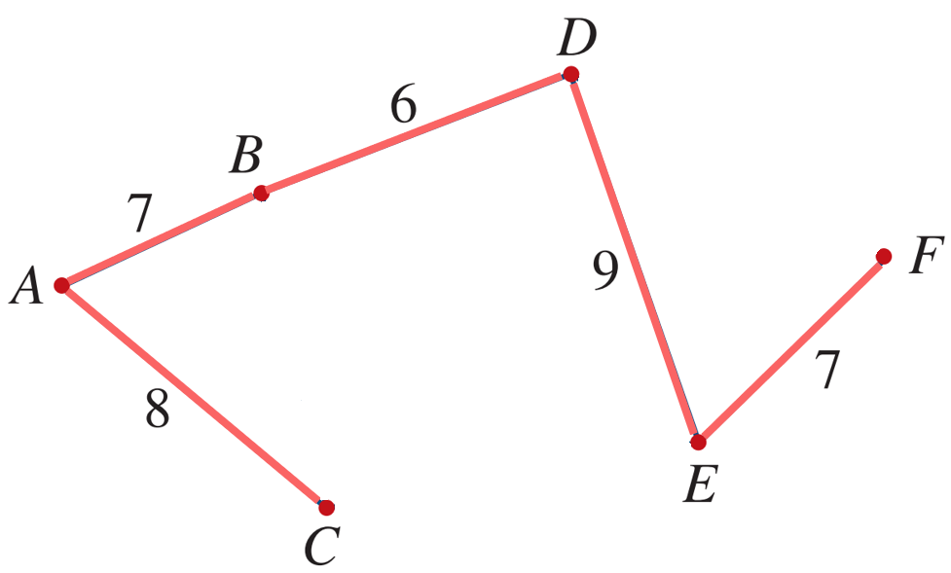
1. Create a minimum spanning tree:

2. Find the length of the spanning tree by summing the edge weights
$7+6+8+9+7=37$
3. Interpret the answer.
The shortest distance of water pipe is 37 km.

- Guided Practice
The weighted graph shows the cost (in millions of dollars) of connecting rural towns using internet cables. Determine the lowest cost of connecting all the towns.
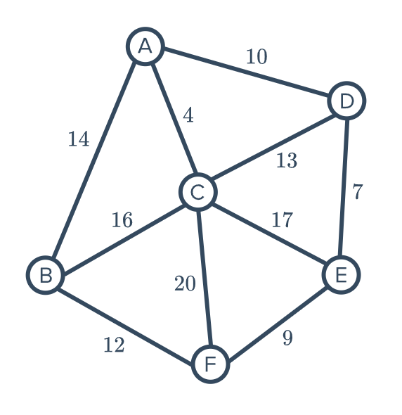

$42 million

Foundation
- Water is to be piped from a water tank to seven outlets.
The possible pipe connections are shown. The distances, in km, are shown as edge weights.
  - Starting at the tank, construct the minimum spanning tree.
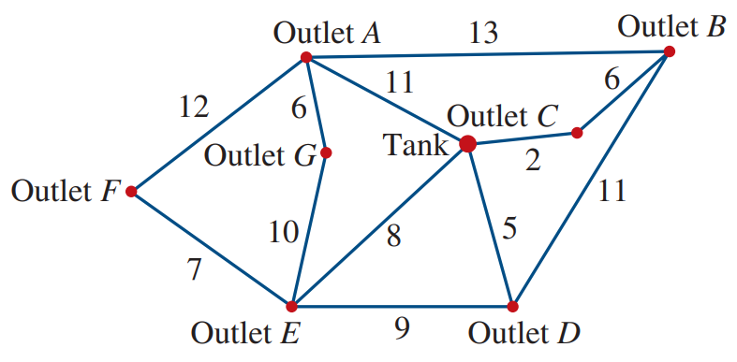

  - What is the minimum length of pipe required?
44 km

- The diagram shows the cost, in dollars, to lay NBN cables to connect suburbs to the node.
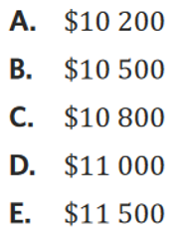
What is the minimum cost required to ensure each suburb is connected to the node?
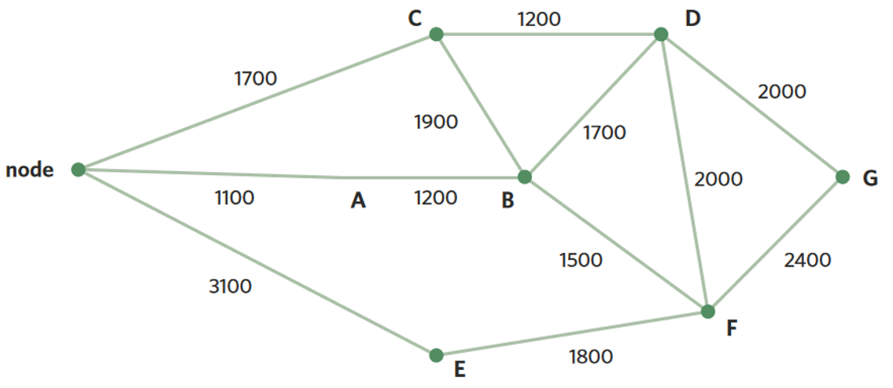
2

B
- What is the minimum amount of cable needed to connect these houses? (all units are in metres)
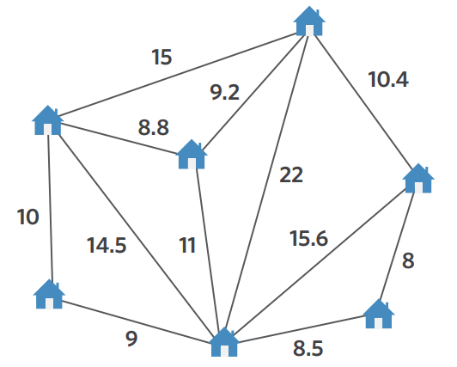

53.5 m

Development
- A Japanese garden is being built, with paths connecting ponds.
The cost to pave the paths is $120 per metre. What is the least cost of the paths?
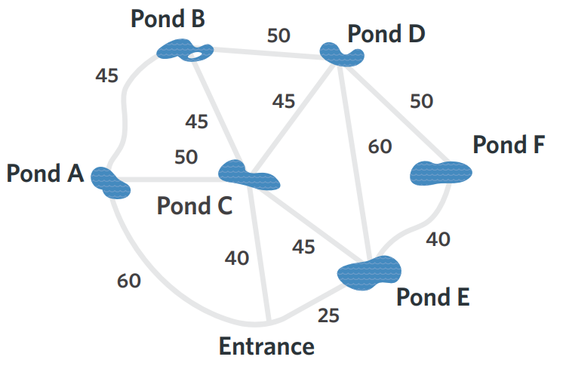

$28 800

- The table shows the distances between towns A, B, C, and D in kilometres.
  - The network is undirected. Fill in the rest of the table.
  - Represent the table as a graph.
 |  | To:
 |  | A | B | C | D
From: | A | - | 3.3 | 5.8 | 2.5
From: | B |  | - | 4.4 | 1.5
From: | C |  |  | - | 3.6
From: | D |  |  |  | -
  - What would be the most cost-effective method of connecting the towns to each other? Answer using a diagram.

  - If the cost per km of rail is $50 000, what is the minimum cost of setting up the network?

$380 000
- Stacey and Julia are building a house. There will be 9 power points throughout the house.
The positions of the power points and the main power source are indicated by the vertices.
The numbers on the edges represent the distances, in centimetres, between the power points.
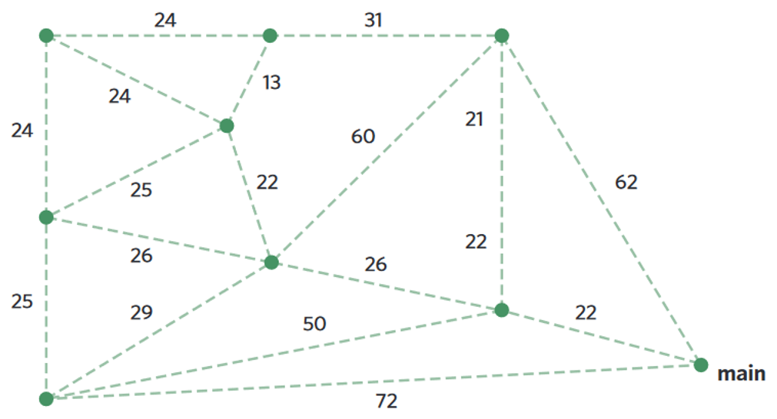
Draw how to connect all power points to the main with the shortest length of cable.
2

  - What is the mathematical name of the graph you have drawn?
  - What is the shortest length of cable needed?
199 m
- 2022 HSC Standard 2 Band 3
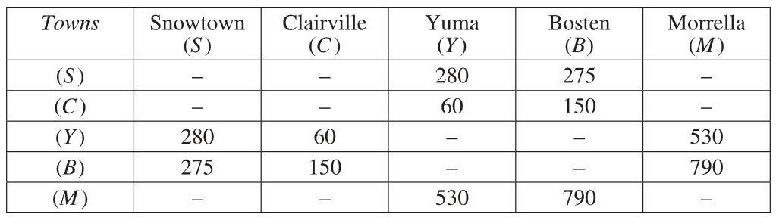
The table below shows the distances, in kilometres, between a number of towns.

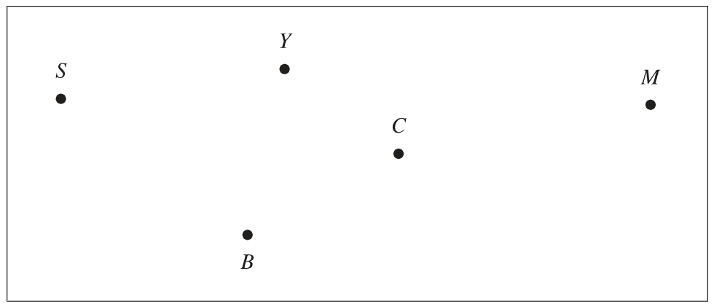
Draw a weighted network diagram to represent the information shown in the table.

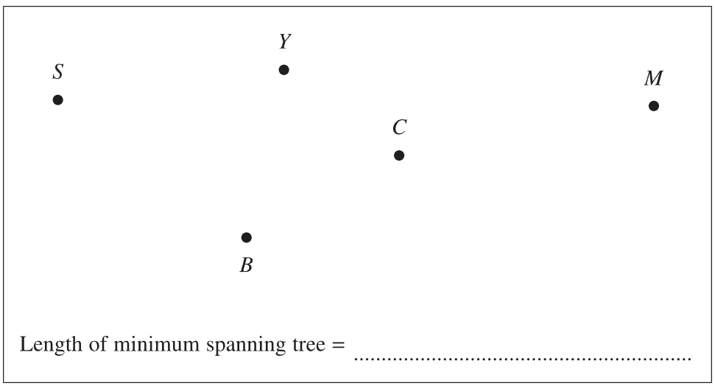
A tourist wishes to visit each town.
Draw the minimum spanning tree that will allow for this and determine its length.

1015 km

Mastery
- 2021 VCE Band 5
A network of roads connecting towns in an alpine region is shown below.
The distances between neighbouring towns, represented by vertices, are given in kilometres.
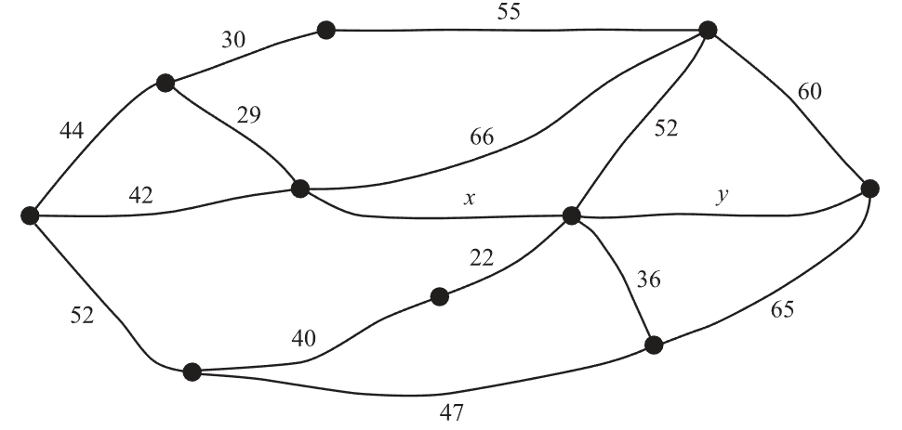

The region receives a large snowfall, leaving all roads between the towns closed to traffic.
To ensure each town is accessible by car from every other town, some roads will be cleared.
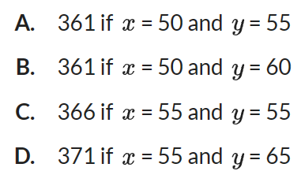
The minimal total length of road, in kilometres, that needs to be cleared is

(hint: draw a partial minimum spanning tree that doesn’t include the edges $x$ and $y$)
B

Shortest Paths

- Shortest Paths
- To find the shortest path between two vertices, it is often easiest to do it by inspection
(guess and check).
- Use reasoning to eliminate paths that take the long way around rather than the direct route.

- Example Determine the shortest path by inspection
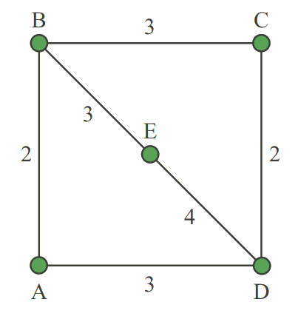
Determine the shortest path between A and E.

Two feasible paths:
A B E: 2 + 3 = 5
A D E: 3 + 4 = 7

The shortest path is A-D-E with total weight of 5.

Why do we not consider paths A-D-C-B-E or A-B-C-D-E?

- Guided Practice
- Determine the shortest path between A and E by inspection and state the length of the shortest path.
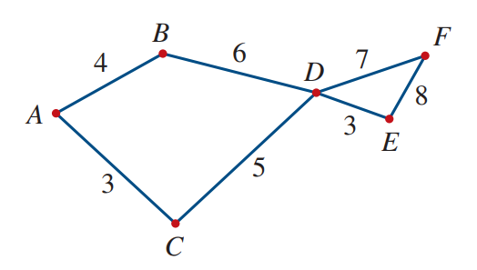

A-C-D-E 11
- The network diagram represents time required to travel along streets between home and the shops. Determine the shortest path and time between home and shops.
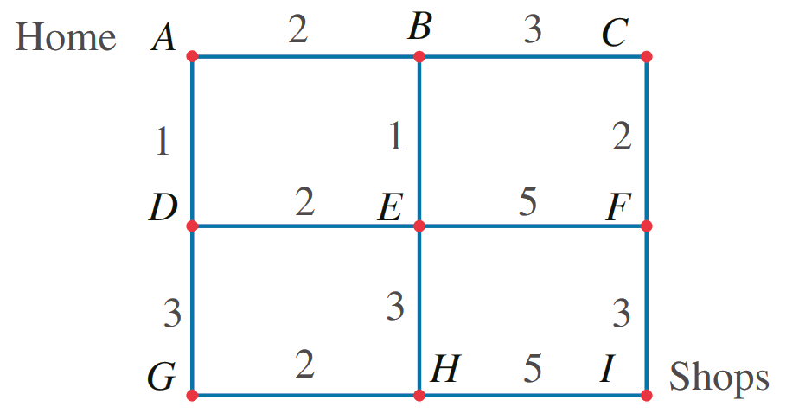

A-B-C-F-I 10 minutes
- Dijkstra’s Algorithm for Finding the Shortest Path
- Redraw the graph with empty circles at each vertex.
- Begin a tree from the starting vertex $S$ given by the question.
For all vertices one edge away from $S$, write the lowest total weight inside the circle.
- For all vertices two edges away from $S$, write the lowest total weight inside the circle.
- Keep going until you reach the finish vertex $F$.
- Identify the shortest path by tracing back from $F$ along the lowest total weights.

- Example Determine the shortest path by inspection
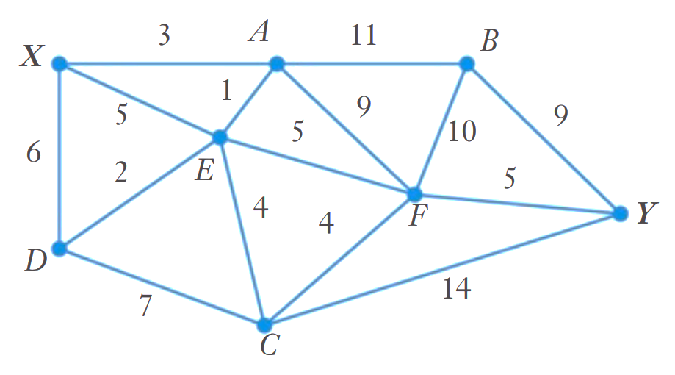
Find the shortest path between $X$ and $Y$.

Step 1: Step 2:
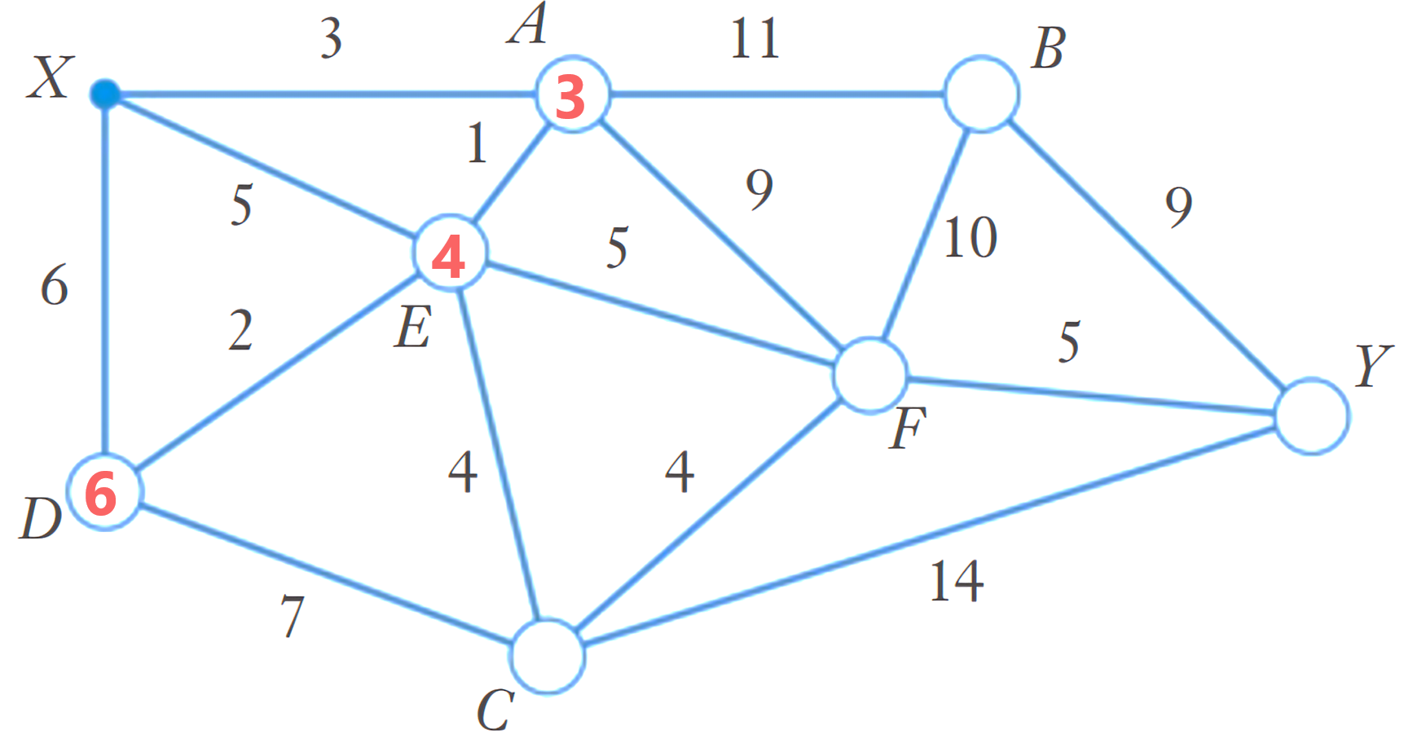
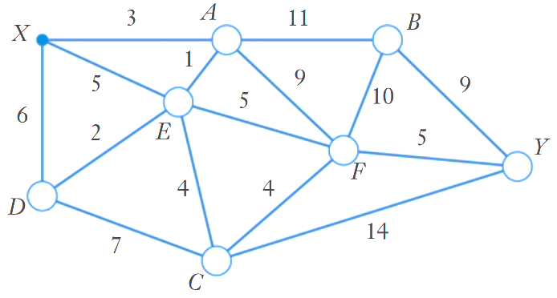

Step 3: Step 4:
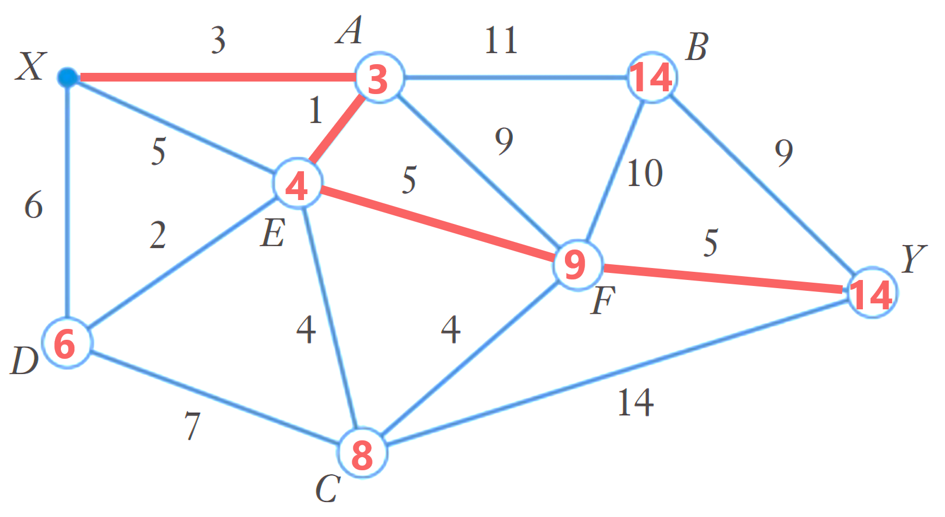
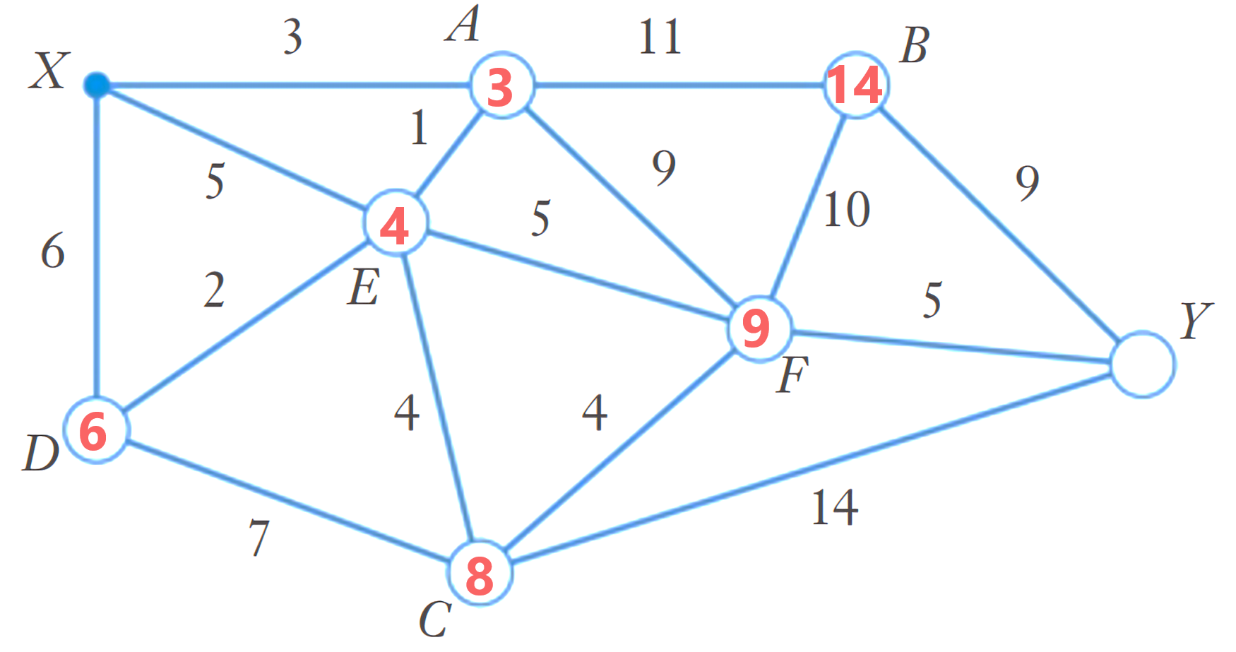

The shortest path is X A E F Y with total weight of 14.

- Guided Practice
Determine the shortest path weight from A to B.
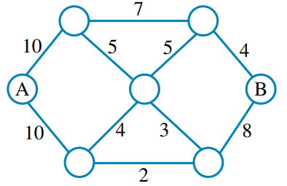  20 | 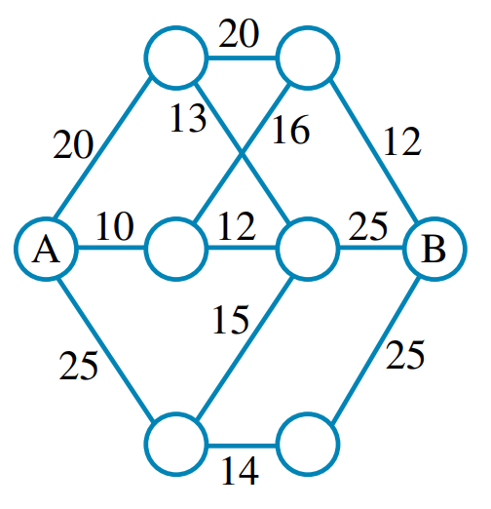  38
Determine the path weight using Dijkstra’s Algorithm
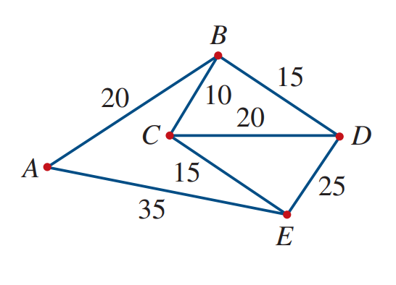  - A to D  35 | - B to D  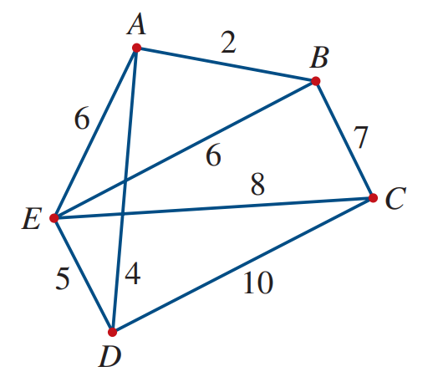  6

Foundation

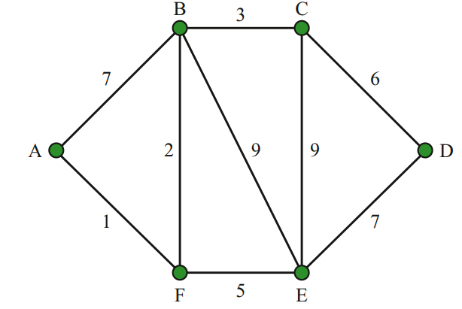
  - Determine the shortest path between A and D.

  - What is the length of the shortest path?

A-F-B-C-D 12
- Determine the lengths of the shortest paths between the given vertices by inspection.
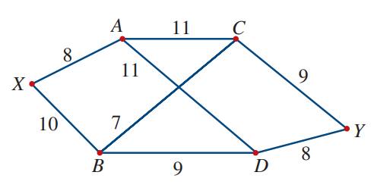
  - X and C
  - X and D
  - A and Y
  - B and Y
  - A and B
  - X and Y
17, 19, 19, 16, 18, 26

- Using Dijkstra’s Algorithm, find the shortest path from S to F and its length.
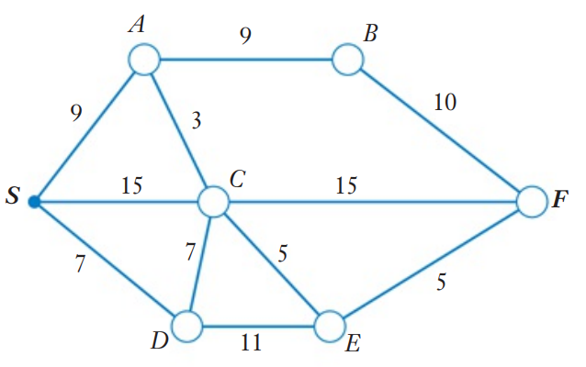

Path: ……………………… Length: …………………………

S-A-C-E-F 22

Development
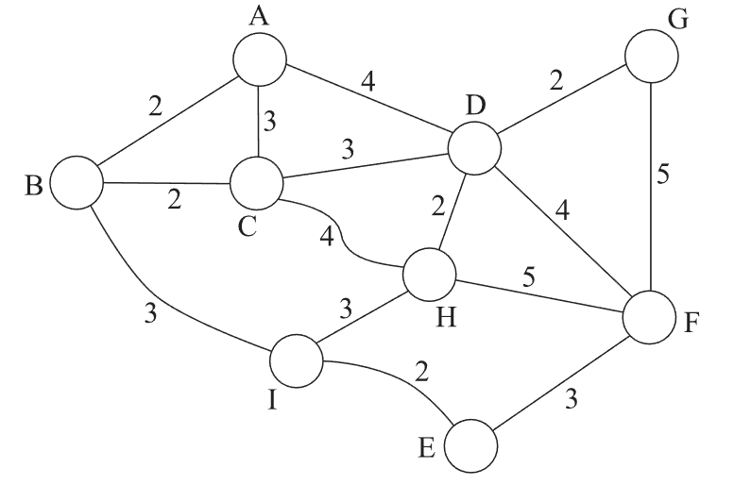
- Consider the graph.
  - Use Dijkstra’s Algorithm to find
the shortest path from A to E.

A-B-I-E 7
  - Construct the minimum spanning tree.
Is the shortest path between A and E on the minimum spanning tree?

No
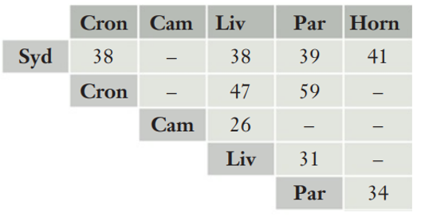
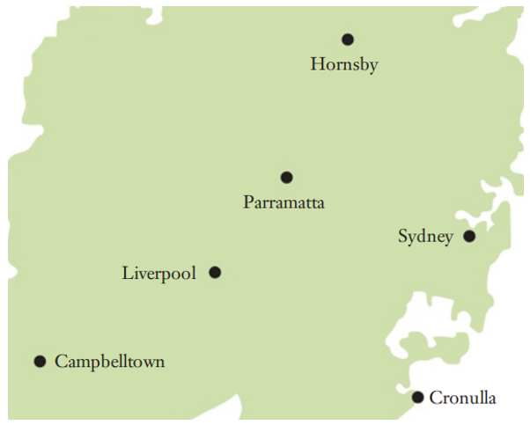
- The table shows the travelling times between 6 locations.
Construct a graph based on the information on the table.

  - Draw the minimum spanning tree for the network. What is the sum of the edge weights?

167
  - Describe the shortest path between Cronulla and Hornsby.
Is it contained on the minimum spanning tree?

Cron-Syd-Horn, no
- HSC Sample Question Band 4
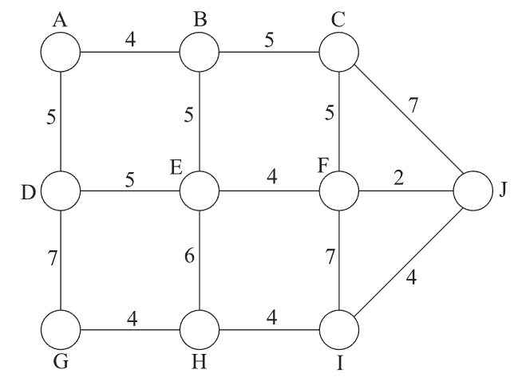
Describe the shortest path between A and J and its weight.

Path: ……………………… Weight: …………………………

A-B-E-F-J 15
- 2014 VCE Band 4
The diagram shows the roads that Stephanie can use to travel between home and school.
What is the shortest time that it will take her to ride her bike from school?
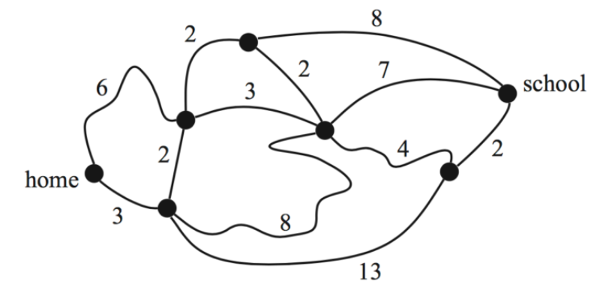

14 minutes

Mastery
- HSC Sample Question Band 5
The following table shows the travelling time, in minutes, between towns which are directly connected by roads. A dash indicates that towns are not directly connected.
Draw a network diagram showing the information in this table.
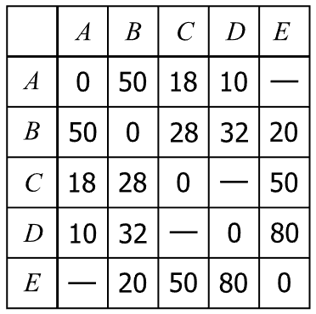

What is the shortest travelling time between A and E?

62 minutes

- HSC Sample Question Band 4
A network of roads is pictured below, with the distances of each road represented in km.
A driver wants to travel from A to H in the shortest distance possible.
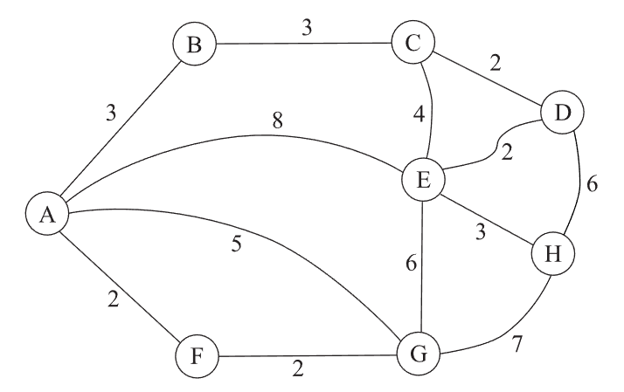
What is the distance she must travel?

11 km
- 2023 HSC Standard 2 Band 5
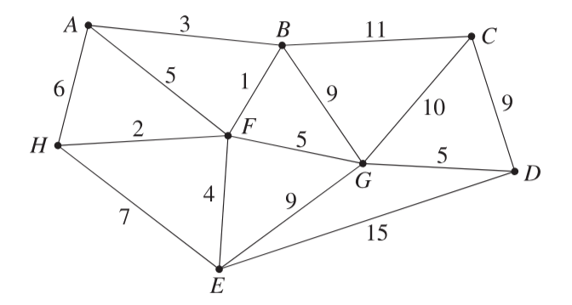
A network of running tracks connects the points A to H, as shown. The number on each edge represents the time, in minutes, that a typical runner should take to run along each track.

  - Which path could a typical runner take to run from point A to point D in the shortest time?

A-B-F-G-D 14 minutes
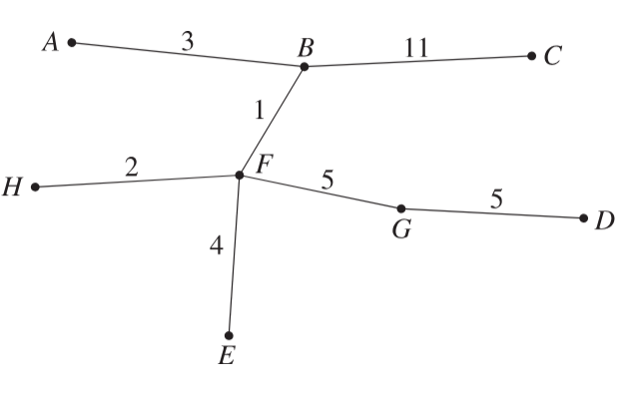
  - A spanning tree of the network above is shown.

  - Is it a minimum spanning tree? Justify your answer.

No, a shorter one is possible.

